**CHAFFEY HIGH SCHOOL**

**TIGERS**

**U.S. NAVY JUNIOR RESERVE OFFICER TRAINING CORPS**



**HONOR, COURAGE, COMMITMENT**

INSTRUCTORS:

MARTIN A JONES HECTOR RAZO

LCDR, US NAVY (RET) MASTER CHIEF, US NAVY (RET)

(909) 921-7274 (619) 292-9323

[Martin.jones@cjuhsd.net](mailto:Martin.jones@cjuhsd.net) [hector.razo@cjuhsd.net](mailto:hector.razo@cjuhsd.net)





***( C H A F F E Y )***

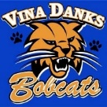



***( V I N A D A N K S )***

**NJROTC CADET HANDBOOK**

**SCHOOL YEAR: \_2023-2024\_**

**(CPM English and Spanish Updated December 2023)**

Table of Contents

Title Page Page 1

Table of Contents (This Page) Page 2

Chaffey High Navy JROTC Mission Statement Page 2

Chaffey High Navy JROTC Vision Statement Page 2

Navy’s Policy on Harassment or Bullying Page 3

Introduction Page 3

This Handbook Belongs to Page 4

Navy Core Values Page 4

Navy JROTC Cadet Creed Page 4

Chaffey Navy JROTC Honor Concept Page 4

***NEW!***  Joint Chaffey HS and Vina Danks Middle School 8th Grade NJROTC Program Page 4

Important Notes and Facts about the Navy’s JROTC Program Page 5

Chain of Command (as of November 8 2023) Page 5

Orders to the Sentry Page 6

Weekly Routine Page 6

Navy JROTC Eleven Principles of Leadership Page 6

Eight Core Leadership Values of Organizations Page 6

Male Grooming Requirements Page 7

Female Grooming Requirements Page 8

Introduction to Naval Science Courses Page 9-10

Safety (Training time Outs) Page 10

Grading Policy Page 11

Personal Goals and Desires Page 12

Are Grades and Promotion Related? Page 12

Time in Unit (TIU) and Time in Rank (TIR) Table Page 13

Promotion to Chief Petty Officer and above Page 13

Cadet Enlisted Ranks Page 14

Cadet Officer Ranks Page 15

NJROTC Ribbon Awards Pages 15-18

NJROTC End of Year Medals Pages 19-20

Criteria for earning the Chaffey NJROTC Graduation STOLE (***Revised***) Page 21-22

Secret to being a “Straight – A – Student” Page 23

A Study system for Reading Assignments Page 24

Naval Academy and Navy ROTC University Scholarships Pages 25-29

Former Chaffey Tigers at (or graduated) from the USNA and Navy ROTC Page 27

US Naval Academy (USNA) Information for 9th through 12 grades Pages 28-29

Where do I fit in? Pages 30

The 24-Hour Clock and Phonetic Alphabet and Navy Signal Flags Page 31-32

Instructor Profiles

LCDR Jones SNSI Page 33

Maser Chief Razo, NSI Page 34

Notes Page 35

## *MISSIONAND VISION OF THE CHAFFEY NAVY JROTC*

**Mission Statement**: ***To assist all enrolled cadets to the greatest extent available based on our training, education, experience, and knowledge to become as involved as they are willing and able to do so during their high school years in academic excellence, sports, drama, clubs, community service, and competitions which will formulate a competitive scholastic and professional foundation for college acceptance and/or any career they desire to pursue.***

**Vision Statement**: ***To see each enrolled cadet develop with a strong sense of confidence and accomplishment, self-respect, self-discipline, self-control, a strong desire to succeed, a strong willingness to be involved, and a willingness to set attainable goals for personal success, which they will then pursue daily.***

**NAVY’S POLICY ON DISCRIMINATION, EQUITY AMONG ALL PEOPLE,**

**HARRASSMENT, BULLYING SUICIDE PREVENTION**

The United States Navy, the Chief of Naval Operations, the Naval Service Training Command, the Naval Education Training Command, The Navy University ROTC and the Navy Junior ROTC (high school) all strictly prohibit direct or indirect harassment, bullying, teasing, or racial, ethnic, religious, gender, discrimination of any kind at all levels.

This is fully and unequivocally supported by the Chaffey Joint Union High School Superintendent, Dr. Mat Holton and all principals in all high schools within the District. In a recent equity statement from Dr Holton, he provide the following words: “As an educator and Superintendent for the CJUHSD, it is my responsibility, *along with the responsibility of our staff*, to examine and revise structures in our schools and classrooms that may deny access and opportunities to our *African American students and* *other students of color*. It is my commitment to you, to our families, and to our students that we will take the steps and actions necessary to bring about substantial change in the outcomes for our students.”

Further, the Chief of Naval Operations (CNO) and all echelons reporting to the CNO, including NETC and NSTC, which the high school Navy JROTC program reports to, demands that all Navy echelons render dignity and respect to all people regardless of ethnicity, culture, or nationality. It’s one of the things that makes us a great Navy.

Furthermore, the US Navy strictly prohibits sexual harassment of any kind at any time. This includes “wolf-whistling”, unwanted touching, statements which make another feel uncomfortable, or any action which is generally or specifically sexual in nature.

If you see or hear of harassment (of any kind at any time), including bullying, discrimination, name calling, disrespect of another or sexual harassment occurring please inform the instructors, a counselor, or any of the principals immediately. If you see something, please, say something. If it is determined that any cadet in a leadership position allows or fails to stop and/or report any type of harassment, intimidation, discrimination or injury to anyone in the unit they may be subject to removal from their leadership position and reduction in rank to C/SR. Please ensure you understand and adhere to the critical position statements and philosophies detailed by the Navy, the District and the instructors.

Chaffey HS Navy JROTC Anti-Bullying and Harassment Officer is: C/ .

*INTRODUCTION!*

For new students, Welcome! You have enrolled in Chaffey High School’s Navy Junior Reserve Officers Training Corps (NJROTC) Program. This program is sponsored and supported by the U.S. Navy (although it is NOT a Military Program) and is similar to the Navy’s ROTC program at USC, UCLA, UCSD, SDSU, Stanford, Berkley, Notre Dame, and 53 other universities across the country, but at the high school level.

However, Chaffey Navy JROTC has enjoyed a strong history of success in developing, mentoring, and guiding outstanding students towards receiving fully paid appointments to both the US NAVAL Academy and to the Navy’s University level ROTC program. Since 2015 we have assisted six students from Chaffey High in receiving these appointments. We hope to continue this excellent trend.

LCDR Jones, a member of the Chaffey High faculty, and the Admission Advisor for the US Naval Academy in this region is keenly interested and involved in helping all students achieve College and Career Readiness, in accordance with the District and School’s goals and objectives.

**THIS HANDBOOK BELONGS TO:**

**NAME\_**\_\_\_\_\_\_\_\_\_\_\_\_\_\_\_\_\_\_\_\_\_\_\_\_\_\_\_\_\_\_\_\_\_\_ **LONG ID:** \_\_\_\_\_\_\_\_\_\_\_\_ **SHORT ID:** \_\_\_\_\_\_\_\_\_\_\_**\_**

##### **ADDRESS** **CITY\_\_\_\_\_\_\_\_\_\_\_\_\_\_\_\_\_\_ ZIP \_\_\_\_\_\_\_\_\_\_\_\_\_**

**PLATOON:** \_\_\_\_\_ **GRADE (8, 9, 10, 11, 12):** \_\_\_\_ **YEARS IN NJROTC:** \_\_\_\_ **RANK:** \_\_\_\_\_\_\_\_\_\_

The US Navy and the Navy Instructors encourage each enrolled cadet to challenge themselves academically, get involved with the program, the school and community, and always do their best. Follow the Navy’s Core Values by being persons of “Honor”, “Courage”, and “Commitment”;

“*Honor”* Earning respect for your work, for being fair, truthful, for refusing to lie, cheat or steal. Honor is always doing and saying what is right.

“*Courage*” Doing right even in the face of ridicule, fear, discouragement, obstacles, hardship. Make decisions which improve yourself and those around you.

“*Commitment*” Dedicate yourself to do what you promised to do. Keep your word.

**THE NJROTC CADET CREED**

I am a Navy Junior ROTC cadet.

I strive to promote patriotism and become an informed and responsible citizen.

I respect those in positions of authority.

I support those who have gone before me to defend freedom and democracy around the world.

I proudly embrace the navy’s core values of honor, courage and commitment.

I am committed to excellence and the fair treatment of all.

###### *THE CHAFFEY NJROTC HONOR CONCEPT*

###### *(Adapted from the US Naval Academy)*

*Chaffey HS Navy JROTC Cadets are persons of integrity: They stand for that which is right.*

*They tell the truth and ensure that the truth is known. . . . . . . .* ***They do not lie.***

*They embrace fairness in all actions. They ensure that work submitted as their own is their own, and that assistance received from any source is authorized and properly documented. . . . .* ***They do not cheat.***

*They respect the property of others and ensure that others are able to benefit from the use of their own property . . . . .* ***They do not steal.***

***This year we are adding 8th Grade Students from Vina Danks Middle School*** under the authority of the Naval Service Training Command (NSTC) in Chicago, Illinois, and with the support and approval of both the Chaffey Joint Union High School District (CJUHSD) Superintendent, and the Ontario Montclair School District (OMSD) Superintendent. This Cadet Policy Manual (CPM) is to be studied, maintained, and used throughout the school year while cadets are enrolled in the program. Cadets enrolled are expected to read, follow and comply with the criteria in this manual. Questions are always welcome to assist with understanding the material in this manual. Please feel free to ask.

WELCOME ABOARD VINA DANKS 8TH GRADE STUDENTS!

*IMPORTANT NOTES ABOUT CHAFFEY NAVY JROTC:*

1. Chaffey Navy JROTC *IS NOT* a military organization, but a citizenship program.
2. Chaffey NJROTC is partially funded by the US Navy, which pays for uniforms, books, some travel, some awards and some college scholarships, if cadets are interested and competitive.
3. Regardless of how long in the program, there is NO military requirement after graduation.
4. Uniforms are loaned for free but must be returned when they leave, or paid for if not returned.
5. Chaffey Navy JROTC classes are normally five days each week (a normal class) and five periods a day. Grades are issued like any normal class
6. Chaffey Navy JROTC cadets do many events in the evenings and on the weekends.
7. Cadets in the 9th grade must take regular PE classes along with their Navy JROTC class.
8. Cadets in the 10th through 12th grade DO NOT need to take regular PE classes because they receive PE credit when enrolled in the Navy JROTC class.
9. The Navy’s JROTC classes are not “CORE” courses but “ELECTIVE” courses, and earn 5 elective credits each semester. 10th and 11th grade cadets earn 5 PE credits as well.
10. Since the US Navy provides some of the funds from the government, the government is required to do inspections on the unit each year and report the findings to Navy headquarters.

CHAIN OF COMMAND (Please Commit to Memory)

Commander in Chief The Honorable Joseph Biden

Assistant Commander-In-Chief The Honorable Kamala Harris

Secretary of State The Honorable Antony Blinken

Secretary of Defense The Honorable Lloyd Austin

Chairman, Joint Chiefs of Staff General Charles Brown, Jr., US Air Force

## Secretary of the Navy The Honorable Carlos Del Toro

Chief of Naval Operations Admiral Lisa Franchetti, US Navy

Commandant of the Marine Corps General David H. Berger, USMC

Chief of Naval Education. & Training RADM [Jeffrey Czerewko](http://www.netc.navy.mil/Who-We-Are/NETC-Leadership/NETC-Leadership-Display/Article/3422621/rear-admiral-jeffrey-czerewko/), US Navy

Naval Services Training Command RADM Craig T. Mattingly, US Navy

Area ELEVEN Manager CDR Thomas Garcia, US Navy, Ret

CJUHSD Superintendent Dr. Mathew Holton

Chaffey High School Principal Mrs. Christina Martinez

Chaffey High School Asst Principal Mr. Trevor Woolery

Senior Naval Science Instructor LCDR Martin Jones, US Navy, (Ret)

Naval Science Instructor Master Chief Hector Razo, USN (Ret)

OFFICERS IN TRAINING

Chaffey Navy JROTC Officer In Training C/CPO Anthony Perez (11th Grade)

Chaffey Navy JROTC Officer In Training C/CPO Samantha Rodriguez (11th Grade)

Chaffey Navy JROTC Officer In Training C/1st Class Karla Melgar (11th Grade)

Chaffey Navy JROTC Officer In Training C/1st Class Elliott Kennedy (10th Grade)

Chaffey Navy JROTC Officer In Training C/2nd Class Christopher Reyes (10th Grade)

**ORDERS TO THE SENTRY** (Please Commit to Memory)

1. Take charge of this post and all government property in view.
2. Walk my post in a military manner, keeping always on the alert, and observing everything that takes place within sight or hearing.
3. Report all violations of orders I am instructed to enforce.
4. Repeat all calls from any post more distant from the guardhouse (quarterdeck) than my own.
5. Quit my post only when properly relieved.
6. Receive, obey and pass on to the sentry who relieves me all orders from the commanding officer, command duty officer, officer of the deck, and officers and petty officers of the watch only.
7. Talk to no one except in the line of duty.
8. Give the alarm in case of fire or disorder.
9. Call the Officer of the Deck in any case not covered by instructions.

10. Salute all officers and all colors and all standards not cased.

11. Be especially watchful at night, and during times for challenging, challenge all persons on or near my post, and to allow no one to pass without proper authority.

*WEEKLY ROUTINE (for 2023-2024) (May be adjusted based on the needs of Vina Danks)*

Mondays Physical Fitness Day

Tuesday Academics

Wednesday Academics

Thursday Uniform Day and Drill (Vina Danks students wear all day)

Friday Physical Fitness Day

# *THE NAVY JROTC ELEVEN PRINCIPLES OF LEADERSHIP*

1. Know yourself and seek self-improvement.
2. Be technically proficient.
3. Seek responsibility and take responsibility in your actions.
4. Make sound and timely decisions.
5. Set the example.
6. Know your people and look out for their well-being.
7. Keep your workers informed.
8. Develop a sense of responsibility in your workers.
9. Ensure that tasks are understood, supervised, and accomplished.
10. Train as a team.
11. Use the full capabilities of your organization.

## *MALE GROOMING REQUIREMENTS*

Hair on male cadets must be cut and clean and should follow the examples provided in the photos below. Plaited or braided hair is unauthorized.



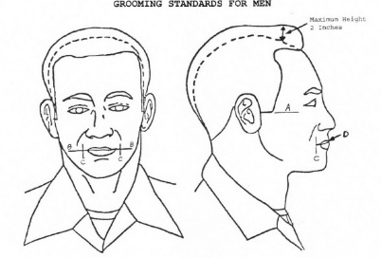

Ethnic hairstyles are permitted provided they are groomed to fit within the guidelines stated above. Bizarre hairstyles and faddish or outrageous multicolor hair are unauthorized.

Sideburns must be neatly trimmed as shown in the photo above. They may not extend below a point level with the middle of the ear as shown by line “A”.

Mustaches must be neat and closely trimmed. They should not extend below the upper lip as indicated by line “D”. No other facial hair is permitted.

Earrings/Studs are not authorized in the ear, nose, eyebrows, tongue, lips or other areas of the face or body visible to others.

Necklaces are authorized but may not be visible. Cadets are authorized one ring per hand; Cadets are authorized one wristwatch and one bracelet.

A conservative pair of sunglasses when, authorized by instructors, but never in formation.

## *FEMALE GROOMING REQUIREMENTS*

Hair on female cadets must be clean, neatly shaped, not lopsided. ,. Braids must be neatly and must inconspicuously secured at all points to the head and may not dangle free. Hair may touch but not fall below the horizontal line parallel with lower edge of the collar. (See line “A” in the picture below on the right.) Hair may not show under the front brim of the any cap.

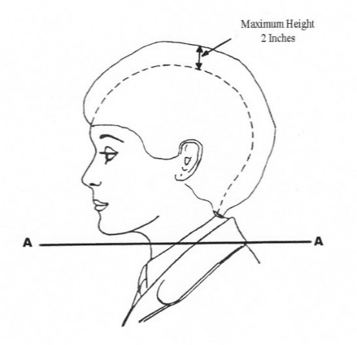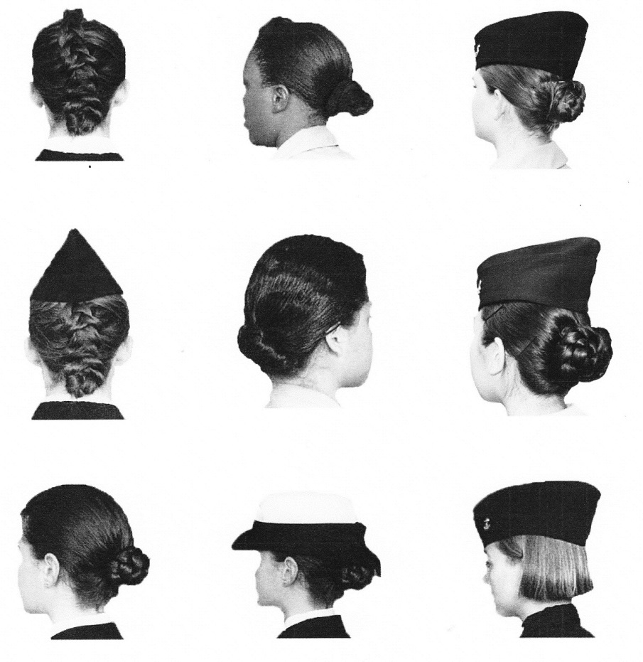

Barrettes and other hair ornaments must be similar to hair color. Rubber bands, combs and pins which are different in color than hair are not authorized.

Cosmetics should be applied in good taste and blend in with natural skin tone.

Nail polish color shall complement the skin tone, and shall not be excessive in length.

One earring is allowed per ear, centered on the ear lobe. It must be a small gold or silver ball (post or screw on). Studs are not authorized in the ear, nose, eyebrows, tongue, lips or other areas of the face or body visible to others.

Necklaces are authorized but may not be visible. Cadets are authorized one ring per hand; Cadets are authorized one wristwatch and one bracelet.

A conservative pair of sunglasses when, authorized by instructors, but never in formation.

# *INTRODUCTION TO NAVAL SCIENCE COURSES*

**NAVAL SCIENCE 1** Grades: 8-12 5 Elective Credits/Sem plus 5 PE Credits/Sem (for 10-11 Grade)

If this is the student’s first year in a JROTC class, then, regardless of grade level (8, 9, 10, 11 or 12) they are introduced to the Naval Science Program. Subjects include: Introduction to the NJROTC Program, Introduction to Leadership, Citizenship, The Foundations of our Government, Introduction to Military Customs and Courtesies, Wearing of the Naval Uniform, and an Introduction to Military Drill and Ceremonies, understanding College and Career readiness, participating in community and school service events, learning teamwork, participating in regional competitions (when not in a Distance Learning scenario) and laying the foundations for future successes.

Outstanding first year cadets are identified by the following characteristics:

* They are always on time to class and are present every day class is held;
* They learn the information provided to them and get involved in discussions;
* They respect all other students in the class and the program;
* They always dress out in their uniforms on uniform days and dress out in Navy PT clothing on PE days;
* They turn in homework on time;
* They do their best in all other classes they are enrolled in, turning in homework, assisting teachers, and following the course requirements;
* They maintain the highest grades they possibly can, ask questions, and ensure they are completing all required graduates in order to graduate on time;
* They pursue the A to G classes, AP and Honors classes (when able), apply for the free and reduced lunch, and sign up for the PSAT, SAT, ACT and ASVAB tests when offered;
* They seek out responsibility and pursue promotion and advancement when available;
* They volunteer to help coaches, counselors, and other clubs.

The students which demonstrate the above characteristics are invited to test to become Petty Officers, which may fill important leadership roles and may be assigned additional responsibilities. Truly superior first year cadets, which do all of the items above, and demonstrate ambition, initiative, teamwork, and superior grades and a high Grade Point Average (GPA), may also be offered advanced leadership opportunities during the summer at the Navy’s Sail Academy in San Diego. (Note: this only applies to 9, 10 and 11 grade students)

**NAVAL SCIENCE 2/3** GRADES: 10-12 2 SEMESTERS CREDITS: 5 EACH SEMESTER

ADDITIONALLY, 10-12 GRADES CADETS RECEIVE PE CREDIT

***Prerequisites:*** Naval Science 1 or Instructor approval.

The student is exposed to an intermediate level within the Naval Science program. Subjects include Maritime History, Navy Ships and Aircraft; Oceanography; Meteorology and Weather; Astronomy, Physical Sciences, and advanced Military Drill and Ceremonies. Outstanding second and third-year cadets are identified by the following characteristics:

* They are punctual to ALL Classes and are attend all classes every day class is held;
* They develop discussions and assist in leading discussions among other junior class members;
* They demonstrate respect towards all other students in the program including all other periods, and set the example for respect and strong moral character in every class they are enrolled in;
* They set the example on Navy uniform days as well as on Navy PT days;
* They not only turn in homework on time in all other enrolled classes, but they assist other students with completing all homework in all other classes. Where needed, they mentor, or assist others in understanding more advanced material;
* They do their best in all other classes they are enrolled in, turning in homework, assisting teachers, and following the course requirements;
* They maintain the highest grades they possibly can, ask questions, and ensure they are completing all required graduates in order to graduate on time;
* They pursue the A to G classes, AP and Honors classes (when able), apply for the free and reduced lunch, and sign up for the PSAT, SAT, ACT and ASVAB tests when offered;
* They seek out responsibility and pursue promotion and advancement when available;
* They volunteer to help coaches, counselors, and other clubs.
* They demonstrate superior community service and school support service throughout the year. They assist the instructors, the counselors, all teachers, and the Chaffey Administration in ensuring a sharp and professional appearance on the campus, and take obvious pride in representing Chaffey Tiger Spirit and enthusiasm.

Third Year cadets are instructed at an advanced level within the Naval Science program. Subjects include: Sea Power and National Security, Naval Operations and Support Functions, Military Law, International Law and the Sea, Ship Construction and Damage Control, Shipboard Organization, Basic Seamanship, Marine Navigation, Rules of the Road and Maneuvering Board, Naval Weapons and Aircraft, and supervision of Military Drill and Ceremonies. Truly superior second and third-year cadets will be offered advanced Leadership Training at the Marine Corps Base at Pendleton, in Oceanside, or Fort Huachuca in Arizona. The cost is usually around $180 per cadet. Truly Superior third year cadets are invited to consider visiting the US Naval Academy during the summer to participate in the Naval Academy Summer Seminar.

**NAVAL SCIENCE 4**

GRADE: 12 2 SEMESTERS CREDITS: 5 EACH SEMESTER

***Prerequisites:*** Complete Naval Science 2 and 3 or Instructor approval.

The student is exposed to a number of case studies revolving around leadership style, ethics, finance, budgetary planning, life plans, college and career plans, and readiness for graduation. As senior, fourth year cadets they are expected to be out front, leading, planning, staffing, organizing, executing and capturing lessons learned and “best practices” for follow-on cadets to learn and glean from.

Additionally, many students which remain for a fourth year in the Navy’s JROTC have developed a desire or hope to at the very least, enlist in one branch of the armed services, be it US Navy, US Marine Corps, US Army, US Air Force, or possibly the US Coast Guard. As a fourth year cadet, NS4’s use this year to complete numerous ASVAB tests, meet with recruiters, plan their career, and work to complete their senior year with high marks and a strong physical fitness platform.

*SAFETY AND TRAINING TIME OUT*

The Senior Naval Science Instructor (SNSI) and Naval Science Instructor (NSI) are responsible for the safe conduct of NJROTC training in the unit. This responsibility cannot be delegated to school administrators, chaperons, or other personnel instructing cadets.

During the conduct of any arduous or potentially high risk (for example events which involve potentially harmful conditions) the SNSI/NSI shall be on site and shall cease the training evolution immediately if any student or instructor experiences apprehension concerning personnel safety, or if there is an indication that a need for clarification of procedures exists.

The Instructors or any cadet may call a “**TRAINING TIME OUT” (or TTO)** by calling out in a loud, clear voice, “**TRAINING TIME OUT”** and by a “T” with their hands over the head. If initiated by a cadet, the instructor shall repeat, **“TRAINING TIME OUT”** and halt the evolution until the situation is deemed safe and all cadets are comfortable moving forward.

In those situations, wherein a cadet refuses to participate in training after instructions have been provided, or when excessive use of TTO occurs, the cadet shall be excused from that training evolution.

ORM (Operational Risk Management) is a process which enables instructors and senior cadets to evaluate safety hazards which could occur during an event and mitigate or eliminate these hazards before the event occurs. It involves evaluating the physical layout where the event will take place, the weather, the equipment to be used, and the actual activities cadets must complete.

Where hazards might exist, instructors and senior cadets may develop both administrative and engineered solutions which will alert all cadets to the hazard and create a means of avoiding or working around these hazards so that injuries are eliminated or reduced. More can be read about ORM and safety preparations in the Chaffey NJROTC ORM Plan.

# *GRADING POLICY*

1. **ACADEMIC PERFORMANCE AREAS.** **(60%)**
2. Legal paperwork submission (SPORT PHYSICAL, STD RELEASE, HRSQ) 10%
3. Official Ceremonies (Annual Inspection, Installation of Cadets, All Parents Day, Advancement and Awards) 20%
4. Homework, classwork, tests, quizzes, exams (includes Country Speeches 9-11 Grade / Econ Assign 12 Grade) 20%
5. Navy JROTC Uniform Wear and Hair and Nail Grooming 20%
6. Navy JROTC Navy PT Clothing Wear and PE Participation 20%
7. Community Service and School Support Service (15 hours each semester) 10%
8. **CITIZENSHIP PERFORMANCE AREAS.** **(30%)**
   1. Attendance (Excellent Attendance in ALL Classes (especially AP and Honors) (***See Note 1 below***) 25%
   2. Tardies (Excellent Punctuality in ALL Classes (especially AP and Honors) (See Note 1 below) 25%
   3. Tiger Spirit Teams (Home Sports Game, Color Guards, Flags) 25%
   4. Unit Service (BTSN, 8th Grade Night, Rallies, Guests Services) 25%
9. **EXTRA-CURRICULAR NSTC / NJROTC AREA 11 COMPETITION AREAS** **(10%)**
   * 1. Sports meets competitions (Troy, Chaparral)
     2. Water competitions (Neptune and Poseidon)
     3. Academic team (Brain Brawl)
     4. Orienteering (Map and compass thru Los Angeles Orienteering Club (LAOC))
     5. Sea-Perch (STEM) competitions
     6. Drill teams (Unarmed, Armed, Regulation And Exhibition)
     7. Cyber-Patriot competitions (computer hacking)

***Note 1:*** UNEXCUSED ABSENCES AND TARDIES. All cadets are expected to attend class consistently and to be punctual (on time to every class). Your grade in Chaffey Navy JROTC will be based partly on this citizenship grade. Unexcused absences will be costly. Although they can be made up in ROAR (Saturday school), it is better to be in school every day. Sicknesses will not count against cadets as they are normally excused. However, to be excused, parents must call in to excuse their student.

The following grade is assigned for Citizenship as follows:

Absences Grade Tardies Grade

1 to 3 Unexcused Absences per semester: 100 1 to 5 Unexcused Tardies per semester 100

4 to 8 Unexcused Absences per semester 70 6 to 9 Unexcused Tardies per semester 70

9 or more Unexcused Absences per semester 0 10 or more Unexcused Tardies per semester 0

**GRADING CRITERIA ABOVE ARE DIFFERENT THAN APTITUDE SCORES;**

**APTITUDESCORING INCLUDES SOME OF THE CATEGORIES ABOVE BUT GOES BEYOND**

Cadets desiring to compete for a Military Academy (US Naval Academy, US Merchant Marine Academy, US Air Force Academy, or West Point Military Academy) will be graded beyond the normal grading criteria listed above. They must demonstrate consistent, long term discipline and motivation by getting involved, while maintaining outstanding grades. The instructors have an excellent record of guiding cadets towards earning the $200,000 to $450,000 scholarships. We encourage you to pursue the items listed in the table below if you want to be considered for these highly valued and extremely competitive options. As the Admission Advisor for the US Naval Academy in Annapolis, Maryland, LCDR Jones can provide all the details if you have any questions.

*(NOTE: NOT BEING INVOLVED IN THE ACTIVITIES BELOW DOES NOT LOWER A CADET’S GRADE IN CHAFFEY NJROTC HOWEVER, IF, HOWEVER, YOU ARE INVOLVED, YOU HAVE A MUCH BETTER CHANCE OF RECEIVING SCHOLARSHIPS TO COLLEGES AND UNIVERSITIES.)*

|  |  |
| --- | --- |
| Overall GPA and Class Standing | Any VAPA group (Drama, Dance, Band, Choir, Etc.) |
| National Honor Society/ CA Scholarship Fed | Science Olympiad, AVID, Academic Decathlon |
| Clubs (Any Chaffey Clubs) | AP, Honors, AVID |
| Sports (Any Chaffey Varsity Sports) | Scouts (Sea/Boy/Girl/Venture/ Police Explorers, Fire Explorers) |

CHAFFEY HIGH SCHOOL NAVY JROTC PERSONAL GOALS AND DESIRES

*(Including Advancement or Promotion to higher ranks)*

The Navy Instructors, more than anything else, hope you work hard in order to go to college as well as to find and enjoy a very successful career where you will thrive, excel, and serve with pride and enthusiasm for many years. We know all of you want to make your parents and teachers proud of you. We are here to help you do just that! College can cost a lot of money. Some students do not have much money, either from their parents or grandparents, or saved in the bank. So, they must work hard and apply for scholarships. The FAFSA is a great scholarship to apply for. Also, Chaffey School District has made many agreements with local colleges for Chaffey students can enjoy “Dual Enrollment”, attending college while in high school. Chaffey College allows you to attend for free if your registered as Chaffey High School Student.

To have a competitive resume, which will help you earn scholarships as well as get hired in high paying jobs, you need to be involved in as many areas as possible, get good grades, study for all exams, attend all classes, and score high on college aptitude tests, like the SAT and ACT.

Chaffey NJROTC is constantly assisting you by getting you involved in many things at school. We will provide you counseling and action plans after every grading period which will assist you in getting better.

However, being advanced to a higher rank (also called advancement or promotion) will help you develop leadership skills as well as skills in administration, supply and logistics, operations, precision performance, leading teams in community service and at many of the competitions we enjoy.

All cadets, including 8th grade Bobcats and all Grades of Chaffey Tigers (regardless of what grade they are in) must start at Cadet/E1 (known as Seaman Recruit) when they are enrolled. In order to be promoted (or advanced) the following is required:

For lower ranks E2 (Cadet/ Seaman Apprentice) and E3 (Cadet/Seaman), the following is required:

* 1. Must have No “F’s” or “D’s” in any class at either Vina Danks or at Chaffey;
  2. Must have an overall Grade Point Average (GPA) or 2.00 or higher;
  3. Must be completing or on track for completing all A to G requirements;
  4. Must be on time to all classes; No more than 4 Unexcused Tardies are allowed per semester;
  5. Must attend all classes; No more than 4 Unexcused Absences are allowed per semester;
  6. Average Uniform Grade is 175 out of 200 points;
  7. Average Physical Fitness Dress and Participation Grade is 175 out of 200 points;
  8. Must complete a minimum of 5 hours of community service (which includes School support Service).
  9. No discipline or suspensions or negative teacher comments.
  10. Must pass a written advancement exam with 80% or higher;
  11. Must pass a drill exam;

For cadets which desire to advance or promote to Cadet E4 (Petty Officer 3rd Class) or higher, all of the following items from above are required plus the following:

1. Cadets must pass the physical readiness test for their gender and age as set b national standards;
2. Cadets must be in their second year
3. Cadets must have completed a minimum of 25 hours total of community service and school support service;
4. Cadets must have participated in at least two southern California competitions;

All cadets must meet certain time requirements in order to be advanced or promoted. The two time requirements include Time enrolled in the Program (known as Time In Unit or TIU) and Timie since they were last advanced or promoted (known as Time In Rank or TIR). A table for these times frames is below.

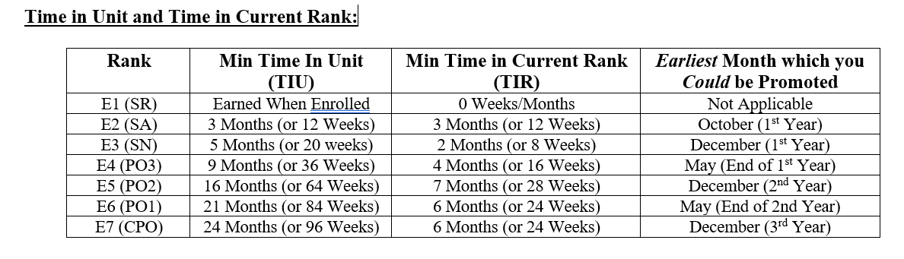

In addition to performing well academically, we strongly encourage all cadets to get involved in the following events at Chaffey HS:

***SPORTS*** (In order to receive credit for Sports a cadet must be on the team roster and play in at least four competitions). Chaffey Sports include Football, Baseball, Golf, Basketball, Volleyball, Wrestling, Cross-Country, Track, Softball, Swimming, Water-Polo, Tennis, and/or Cheer;

***CLUBS*** The following Clubs are currently at Chaffey High: Anime Club, Arcade Club, A.S.B., Ballet Folklorico, BSU, Chess Club, Class Of 23,24,25,26, Community Garden, Dance Team, Debate Team, Entrepreneur Club, Gateways, Hot Elements, Key Club, Kiwins, Latin Dance Club, Leo Club, Link Crew, Mecha, Navy JROTC, Pacific Islander, Spectrum, Tech Club, Thespians, Tiger Buddies, Vocal Music Club, Peer Counseling, T.A.R.T., Renaissance, Yearbook, Young Black Scholars

***FINE ARTS AND EXTRA CURRICULAR*** Band, Drama, Choir, Stage Crew, Link Crew

***ENROLLED IN*** A to G Courses, Advance Placement (AP) and/or Honors Classes, National Honor Society, Principal’s Honor Roll, Civil Air Patrol, Any Scouting (Boy, Girl, Venture, Sea Scouts, etc.) (*Note: more points are earned for achieving Eagle or Gold Awards.*) Police or Fire Explorers

***COMMUNITY SERVICE / SCHOOL SUPPORT HOURS*** We also track and record a cadet’s community service hours when working with the Chaffey NJROTC program, School support Service Hours, like cheering at home football games and providing Color guards for all the sporting events, and assisting other programs and teacher on Chaffey campus.

Promotion to Chief petty Officer and then to the Officer level is very competitive, and always done on a case-by-case situation. Cadets must have earned the rank of C/CPO of Chief Petty Officer or C/E7 before they are eligible for the rank of Officer.

*BECOMING A CHIEF PETTY OFFICER AND ABOVE*

In order for cadets to be considered for Command Staff positions, they must have completed the following

1. They must have remained enrolled in the Chaffey HS Navy JROTC program for a minimum of two years, preferably three years to ensure they understand how to execute their responsibilities;
2. They must have maintained an overall Grader Point Average from all classes of at least 3.00 or higher;
3. They must have completed as minimum of 150 Community Service Hours over the previous two to three years;
4. They must have passed the Navy PRT during the previous year;
5. They must have completed either Navy Sailing Academy in Coronado (San Diego, CA) and/or Navy Advanced Leadership Academy at Pendleton Marine Corps Base under the leadership of qualified Navy JROTC instructors;
6. They must have served in a department head position (Admin, Supply, Operations, Safety, Personnel, Public Affairs, Drill Master, Armory) and applied for the C/Commanding Officer position in writing completing a resume, and answering required questions about their performance;
7. They must attend a panel interview and answer additional questions formed by the Chaffey HS Principal Assistant Principal and/or representative, a coach, a counselor, and the Chaffey HS NJROTC instructors;
8. Each applicant will be graded, and the following year’s Cadet Commanding Officer will be selected based on superior marks. In turn the Cadet Commanding Officer will select their Command Staff.

The difference between Petty Officers and Chief Petty Officers/Officers is simple: ***Chief Petty Officers and*** ***Officers are required to be the VERY BEST of The Petty Officers, and Excel in EVERY Area ALL the TIME****!* They have the Best Grades, Most involvement, serve as the finest example for exhibiting Team Spirit, taking initiative, overcoming problems, taking care of homework, and are THE model of decorum and uniform wear.

The table of the various ranks between Cadet Seaman Apprentice and Cadet/Master Chief Petty Officer is shown in the table below.

**CADET RANKS SEAMAN APPRENTICE THROUGH**

**MASTER CHIEF PETTY OFFICER**

|  |  |  |  |  |
| --- | --- | --- | --- | --- |
| JUNIOR ENLISTED  CADET RANKS  (1ST AND 2ND YEAR) | |  | SENIOR ENLISTED  CADET RANKS  (3RD AND 4TH YEAR) | |
| GRADE/RANK | INSIGNIA |  | GRADE/RANK | INSIGNIA |
| E1 - C/SR  Seaman Recruit  (All new cadets) | NO  INSIGNIA |  | E6 - C/PO1  Petty Officer 1st Class  (4th grade report - 2nd semester) | 34162/p412319088_24069.jpg |
| E2 - C/SA  Seaman Apprentice  (1st progress report) | 34162/p1083701107_24072.jpg |  | E7 - C/CPO  Chief Petty Officer  (Requires 2 years of NJROTC) | 34162/p46079477_24063.jpg |
| E3 - C/SN  Seaman  (1st grade report) | 34162/p1971167157_24074.jpg |  | E8 - C/SCPO  Senior Chief Petty Officer  Requires 2 or more years of NJROTC) | 34162/p618391188_24073.jpg |
| E4 - C/PO3  Petty Officer 3rd Class  (2nd grade report - 1st semester) | 34162/p780569515_24071.jpg |  | E9 - C/MCPO  Master Chief Petty Officer Requires 3 or more years of NJROTC) | 34162/p77498148_24068.jpg |
| E5 - C/PO2  Petty Officer 2nd Class  3rd grade report - 2nd semester) | 34162/p40000067_24070.jpg |  |  |  |

Once you have decided to accept the position of Petty Officer or Officer, you must either fulfill your commitment or you must resign your status and return to a C/Seaman. You cannot hold a Petty Officer or Officer rank and choose to not perform the work associated with the rank. Period!

PRIVELEGES OF BECOMING A PETTY OFFICER

1. You get to ***LEAD*** others! 2. You ***LEARN***! 3. You are ***IN CHARGE*** of events!

The privileges of being a Petty Officer or Officer include receiving the favor, praise and endorsement of those in authority in School, the District, the Community, as well as those in authority in the Naval and Marine Corps leadership ranks. This can lead to positive letters of recommendation, nominations to academies, additional training, awards for performance, and additional responsibility, if desired.

**CADET RANKS ENSIGN (O-1) THROUGH**

**COMMANDER (O-6)**

|  |  |  |  |  |
| --- | --- | --- | --- | --- |
| **GRADE/RANK** | **INSIGNIA** |  | **GRADE/RANK** | **INSIGNIA** |
| O1 - C/ENS  ENSIGN | http://www.oocities.org/pentagon/bunker/5841/Rank/Navy/officers.gif |  | O4 - C/LCDR  LIEUTENANT  COMMANDER | http://www.oocities.org/pentagon/bunker/5841/Rank/Navy/officers.gif |
| O2 - C/LT(jg)  LIEUTENANT  (JUNIOR GRADE) | http://www.oocities.org/pentagon/bunker/5841/Rank/Navy/officers.gif |  | O5 - C/CDR  COMMANDER | http://www.oocities.org/pentagon/bunker/5841/Rank/Navy/officers.gif |
| O3  LIEUTENANT C/LT | http://www.oocities.org/pentagon/bunker/5841/Rank/Navy/officers.gif |  | O6  CAPTAIN C/CAPT | http://www.oocities.org/pentagon/bunker/5841/Rank/Navy/officers.gif |

**NAVY JROTC RIBBONS**

## Cadets desire to show that they’re motivated, skillful, able to lead others, and capable of completing assigned tasks. One way to do this is by earning and wearing Navy JROTC ribbon awards. Ribbons show others your hard work and dedication. NJROTC ribbon awards come in two categories: A) Awarded when earned; B) Awarded ONCE each year at the award ceremony.

1. Ribbons AWARDED WHEN EARNED throughout the year, include the following:

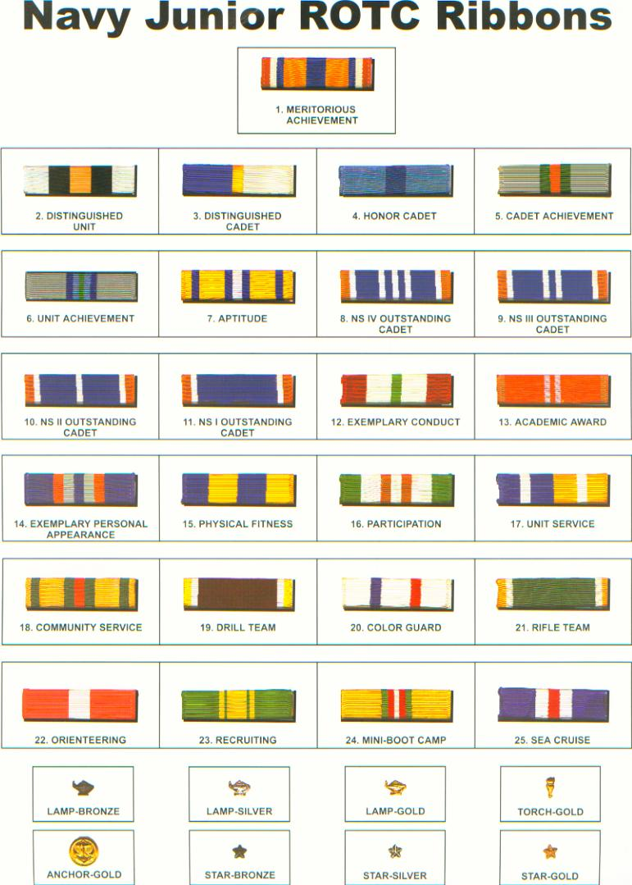

RIBBON NAME HOW DO I EARN IT?\_\_\_\_\_\_\_\_\_\_\_\_\_\_\_\_\_\_\_

14 Exem. Personal Appearance Cadets must receive an “Outstanding” on their Uniform during the AMI.

15 Physical Fitness Cadets MUST have all 3 documents on file (Release Form, HRSQ, Pre-Sports Physical) , and must score high enough on Curl-Ups, Push-Ups and the One-Mile Run. All 3 must be passed. See the Cadet Reference Manual (CRM) for specific criteria based on gender and age.

16 Participation Must complete at least 3 events in any category (Drill, Community Service, Color Guard, Orienteering, Academic Competition, Brain Brawl, Unit Service).

17 Unit Service Must complete a minimum of 15 hours of school support

18 Community Service Must complete a minimum of 20 hours of community service.

19 Drill Team Must compete in at least 3 competitions on either the Armed or Unarmed Drill Team.

20 Color Guard Must complete at least 3 Color Guard events at school, in the community or at competition.

21 Rifle Team Must complete at least 3 air rifle competitions

22 Orienteering Must complete at least 3 Orienteering competitions (Map and Compass)

23 Recruiting Must recruit at least two new cadets who remain in the program for the semester and receive a passing grade.

24 Basic Leadership Training Must complete one 3-day introductory training session. Designed for First Year cadets with no previous knowledge of NJROTC.

25 Sea Cruise Must get underway on a ship, boat or other sailing vessel, away from the shore and pier and return.

1. Ribbons AWARDED ONCE ANNUALLY include the following:



RIBBON NAME HOW DO I EARN IT?\_\_\_\_\_\_\_\_\_\_\_\_\_\_\_\_\_\_\_

1 Meritorious Achievement Issued by the Area Eleven Area Manager to the cadet(s) who consistently demonstrated the highest level of dedication to the unit at every turn. Cadets must have earned the Academic ribbon, the Outstanding NS1, 2, 3, and/or 4 Award, as well as the Aptitude Ribbon in order to qualify for this award.

2 Distinguished Unit Awarded by Naval Education Training Center (in Chicago and Florida) after comparing the level of performance of all 580 Navy JROTC high school unit End of the Year point totals. This is a very prestigious award and it requires among other things strong academic performance, completion of the SAT/ACT Prep program, college acceptance, cadet club and sport involvement, strong community service involvement strong involvement in Area competitions and winning competitions at the highest level. School which do not practice or get involved, usually do not win this high award from Navy Headquarters.

3 Distinguished Cadet Issued to the cadet in each year group (9, 10, 11, 12) which had the greatest positive contribution to the NJROTC unit including but not limited to personal overall scholastic standing, aptitude, homework, physical fitness, community service, drill performance, color guard performance, positive attitude and bearing. Cadets must have earned the Outstanding NS1/NS2/ NS3/NS4, as well as the Aptitude Ribbon in order to qualify for this award.

4 Honor Cadet Issued to the cadet in each year group (9, 10, 11, 12) which had the highest overall academic/scholastic achievement from all courses, with an NJROTC grade of 4.00 (A)

5 Cadet Achievement Issued by area manager based on exceptional, long term performance and significant contributions in all areas. Must have earned the NJROTC Aptitude Ribbon before being considered for this award.

6 Unit Achievement Issued by Area Eleven, Area Manager based on the unit’s performance as reflected in the end of year report. It is similar to the Distinguished Unit Award, but a lower award.

7 Aptitude Aptitude is more than just a cadet’s grade in NJROTC. It is a measure of the cadet’s total involvement and strong performance in ALL areas in school that the Navy JROTC program is involved in. It requires extensive dedication, commitment, academic excellence, community service, physical fitness, uniform wear, positive attitude and development of leadership. Specific requirements include:

1. Submitted all legal paperwork: (Standard Release, HRSQ, and Pre-Sports Physical);
2. Earned the Outstanding NS1, 2, 3, and/or 4 Ribbon during the year;
3. No record or report of discipline for the year;
4. 2.25 overall GPA or higher all courses; 3.00 (B or higher) in NJROTC;; No “F’s” in any other class;
5. Average uniform grade of 85% for year; less than 2 missed uniforms;
6. Earned the Navy PRT Ribbon (or if cadet has Asthma, successfully did C/U and P/U)
7. Present at the Annual Military Inspection (AMI);
8. At least 25 hours of community service for the year;
9. Participated in at least two competition events (Academic, Brain Brawl, College Options, Orienteering, Drill Qualifier Field Meet, Air Rifle, Cyber-Patriot, or Sport Meet);
10. Participated in a school Sport and/or Club for the whole year.
11. Contributed a significant amount of time to help the Admin or Supply Department;
12. Participated in the Annual Military Ball the prior year (for NS2, NS3, and NS4 cadets;
13. Recommended by the command staff and the Naval Science Instructors;

8/9/10/11 Outstanding NS4/3/2/1 Outstanding cadets are just that: THEY ARE OUTSTANDING! Cadets which do not get involved, or participate, or wear their uniform, or attend functions the Chaffey NJROTC Battalion is involved in, or complete community service, or keep their grades up, or who get into trouble, or are tardy, do not qualify for the title of “OUTSTANDING CADETS”, and will not receive this ribbon. You must have completed each successive year of the program to receive each successive award. For instance, you cannot earn the Outstanding NS4 award just because you are a senior (12th grader). You must have been in the program for four years. Specific requirements for this award include the following:

1. No record or report of discipline for the year
2. 2.25 overall GPA all courses; 3.00 (b) or higher in NJROTC; No “F’s” in any other class
3. Average uniform grade of 80% for semester; less than 2 excused missed uniforms;
4. At least 20 hours of community service for the year;
5. Participated in at least one competition event (Academic, Brain Brawl, College Options, Orienteering, Field Meet, Air Rifle, Cyber-Patriot, or Sport Meet)
6. Completed at least one major area (Math, Verbal, Writing) of the SAT/ACT test prep course
7. Participated in at least one fund raising event raising a minimum of $30.00
8. Participated in the Annual Military Ball
9. Recommended by the command staff and the Naval Science Instructors

12 Exemplary Conduct No record or report of discipline; Overall GPA of 2.00 or higher, Grade of “B” or higher in NJROTC; No “F’s” in any course; Average uniform grade 80% and less than 2 excused missed uniforms; 10 or more Community Service hours

13 Academic Award 3.00 overall GPA all courses; 4.00 (A) in NJROTC; Participated in at least 2 academic exams, including the NAE, or 2 or more BB or College Options Program.

**NAVY JROTC END OF YEAR AWARD MEDALS**

## At the end of the year, Chaffey High School Navy JROTC invites a number of distinguished organizations to attend their annual award ceremony. These organizations are usually associated with various Fraternal Veteran Groups from across the nation, and take great pleasure in recognizing and awarding OUTSTANDING service, Academic Achievement, and Team Spirit.

## Cadets desiring to receive one or more of these medal awards must strive to consistently perform at a much higher level than most cadets in the Navy’s JROTC program. Specific criteria for being nominated for one of these awards are below:

## 

|  |  |  |
| --- | --- | --- |
|  | **AMERICAN LEGION**  MILITARY APTITUDE | Presented to one NS2/3/4 who: A. Ranks in the top 25% of their Naval Science Class; B. Demonstrates outstanding qualities of Leadership and Outstanding Uniform wear;  C. Always gets involved, sets the example for others to follow in areas of community service, academics, drill, physical fitness, and school service. D. Demonstrates outstanding moral character and citizenship. |
|  | **AMERICAN LEGION**  SCHOLASTIC  APTITUDE | Presented to one NS2/3/4 who: A. Ranks in the top 10% of their Naval Science Class; B. Demonstrates outstanding uniform wear;  C. Always gets involved in community service, academics, drill, physical fitness, and school service. D. Maintains a GPA of 3.50 or higher in all classes for the year; E. Gets involved in at least 1 school Club and/or sport for the year; F. Demonstrates outstanding moral character and citizenship. |
|  | **ORDER OF**  **DAEDALIANS** | The Order of Daedalians, the National Fraternity of Commissioned Military Pilots, is presented to one Junior which demonstrated: A. Patriotism, love of country, and service to our nation; B. Has indicated the potential and desire to pursue a military career; C. Ranks in the upper 10% of their JROTC class;  D. Earned an Overall GPA of 3.25 or higher for the year; E. Got involved in the unit and set a positive example; F. Ranks in the top 20% of their high school class. |
|  | **DAUGHTERS OF THE AMERICAN REVOLUTION**  **AWARD** | Be a Senior in the NJROTC program with two or more years, who; A. Is in the top 25% percent of their Senior class in all subjects, including NJROTC; B. Demonstrated qualities of dependability, good moral character, and reliably supported unit and school functions, good attendance and had no discipline; C. Demonstrated adherence to military discipline, including consistent decorum, respect for authority, respect for the Flag and the US Constitution, and respect for the uniform; D. Strong leadership ability, including providing consistent encouragement and motivation to junior cadets to do their best and to improve, and; E. Consistently reflected a fundamental and patriotic understanding of the importance of JROTC training |
|  | **SONS OF THE AMERICAN REVOLUTION**  **AWARD** | Presented to an outstanding NS2/3/4 who: A. Demonstrated a high degree of leadership qualities, an overall GPA of 2.50 all classes, involved with school clubs and/or sports, community service; B. Strong military bearing, including proud, consistent wearing of the uniform, respect towards the constitution and the American Flag, and excellent military bearing and decorum at all times; C. General excellence in attitude and support towards the JROTC program, the instructors, good manners, punctuality, and support of school policies. |
|  | **ORDER OF**  **THE PURPLE HEART** | Presented to an outstanding NS2/3/4 who: A. Has a positive attitude toward JROTC and country; B. Holds a leadership position in JROTC; C. Is highly active in school and community affairs; D. Has earned an overall GPA of 3.00 or higher in ALL subjects for the previous semester; |
|  | **MILITARY**  **ORDER OF**  **WORLD WARS**  **(MOWW)** | This award is to be presented to an NS-I cadet who; A. Excels in all military and scholastic aspects; B. Maintains the highest military decorum, personal discipline, and overall GPA of 3.00 or above in all subjects; C. Involved in extracurricular activities, including sports and community service, and individual endeavors, including outside organization involvement, a desire to serve our nation. ; D. Has committed to continue the Nautical Science program for the next school year. |
|  | **MILITARY**  **OFFICERS ASSOCIATION OF AMERICA**  **(MOAA)** | This award is to be presented to a Junior (11th Grade) cadet with 2 or more years who; A. Demonstrates outstanding moral character, strong citizenship; Teamwork, and a Positive “Can-Do” attitude; B. Maintained an overall GPA of 2.25 or higher C. Demonstrates a high order of loyalty to their unit, school and country, always trying to improve the unit, and D. Demonstrates exceptional potential for military leadership (fair, leads by example, helps others, strong community service). |
| ROTC medal | **RESERVE**  **OFFICERS ASSOCIATION**  **(ROA)**  **AWARD** | Cadets who may receive this award must: A. Demonstrates a positive attitude toward the Naval Science curriculum; B. Exhibits excellent personal appearance (consistent, professional wear of the uniform, posture, and grooming); C. possesses exceptional personal attributes (initiative, judgment, and self-confidence); D. displays courtesy (punctuality to class, promptness, obedience, and respect); E. have strong growth potential (capacity for responsibility, high productivity, adaptability to change, maintenance of the highest personal and ethical standards, and strong positive convictions |
|  | **SCOTTISH RITE**  **FREE-**  **MASONRY**  **AWARD** | Cadets eligible for this award must be an outstanding NS2/3/4 who: A. Have contributed the most among cadets on campus to encourage and demonstrate Americanism by deeds or conduct during participation in extracurricular activities or community service projects. B. Have demonstrated academic excellence by being in the top 25% of his or her academic class with a “B” (3.00) in all subjects; C. Have demonstrated a potential for outstanding leadership by exhibiting qualities of dependability, good character, self-discipline, good citizenship and patriotism. |
|  | **NATIONAL**  **SOJOURNERS** | Outstanding NS1/2/3 who A. Ranks in the top 25% of all their academic classes achieving a 2.50 overall GPA (B+) in all classes; B. Encourages and demonstrates ideals of Americanism both within the NJROTC CORPS and on campus; C. Demonstrates potential for outstanding leadership |
|  | **STEPHEN DECATUR**  **1ST YEAR**  **AWARD** | Possess a character reflecting the Navy's core values of Honor, Courage and Commitment, and who A. Demonstrates leadership potential; B. Demonstrates an aptitude in NJROTC as evidenced by motivation; C. Performance of duty and military bearing; D. Receives a "B" or better in NJROTC during the current year and also; E. Has a minimum of a cumulative "B" average in academic studies. |
|  | **STEPHEN DECATUR**  **3rd YEAR**  **AWARD** | Has been in the program 3 years and possesses a character reflecting the Navy's core values of Honor, Courage and Commitment, and who  A. Demonstrates leadership potential; B. Demonstrates an aptitude in NJROTC as evidenced by motivation; C. Performance of duty and military bearing; D. Receives a "B" or better in NJROTC during the current year and also; E. Has a minimum of a cumulative "B" average in academic studies. |
|  | **VETERANS**  **OF**  **FOREIGN**  **WARS**  **AWARD** | Presented to an outstanding NS3/4 with two or more years who: A. Attains a grade of "B" (3.00 or higher) GPA is all subjects; B. Has a positive attitude towards NJROTC; C. Has outstanding military bearing and conduct; D. Possesses strong positive personal attributes such as courtesy, dependability, punctuality, respect, and cooperation); E. Demonstrates patriotism (such as being a member of the color guard or drill team) and actively promotes Americanism; F. Demonstrates leadership potential; F. Active in student clubs/sports |

*CRITERIA FOR EARNING THE CHAFFEY NJROTC STOLE*

1. *Must Complete at least THREE (3), preferably FOUR (4) FULL years in the NJROTC with Honor; NOTE: Discipline of any kind at any time, in any place, on or off school campus eliminates a cadet’s opportunity to receive the Chaffey NJROTC STOLE. Honor is the Keel or Foundation of the Naval Academy, University Navy ROTC and High School Junior Navy ROTC Programs.*
2. *Must Complete A-G Requirements*
3. *Must have maintained a 3.25 GPA or higher during all four years; No “F’s or “D’s” in any course throughout your entire time at Chaffey High School.*
4. *Must have earned the rank of C/Chief Petty Officer or above by the time of the 3rd or 4th year and remained at or above this rank; Reductions in rank due to failing courses eliminates a cadet’s opportunity to receive the CHAFFEY NJROTC STOLE.*
5. *Must have completed a minimum of 250 (or more community service and school support hours over the past three to four years;*
6. *Must have maintained unexcused absences and unexcused tardies below 4 each semester over all four years they were enrolled in Chaffey NJROTC)*
7. *Must have participated in at least two parades during their enrollment in Chaffey NJROTC*
8. *Must have applied to at least three colleges and or universities in their senior year and received a reply from each of the colleges they applied to; (being accepted is not a requirement; applying for colleges or universities is a requirement);*
9. *Applied for FAFSA in their senior year;*
10. *Must have taken the PSAT during their Sophomore year, and their SAT and/or ACT exam at least once in their Junior and/or Senior Year;*

# *Must have commanded a drill team, academic team, color guard team, physical fitness team, or exhibition drill team at two or more Area 11 drill / academic / physical fitness qualifier;*

# *Must have demonstrated outstanding partnership with other Chaffey High School Clubs, Sports, and Programs (Drama, Dance, Choir, etc.) for at least one year over their four years at Chaffey High School;*

# *Must have served as an Officer-in-Charge (OIC) for at least two community service events and two school support events in both their Junior and Senior Years;*

1. *No discipline of any kind during all four years of enrollment in Chaffey NJROTC*
2. *No negative attitudes, disrespect, arrogance towards senior cadets, instructors, other teachers, or authorities;*

*Note: Applying for and/or entering the military after graduation IS NOT a requirement for the CHAFFEY NJROTC STOLE.*

**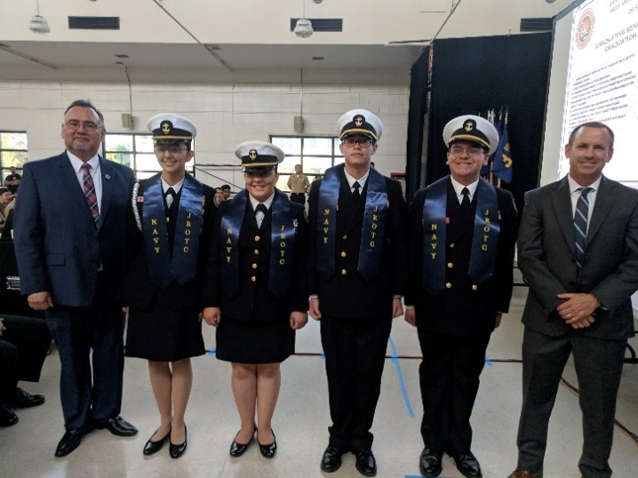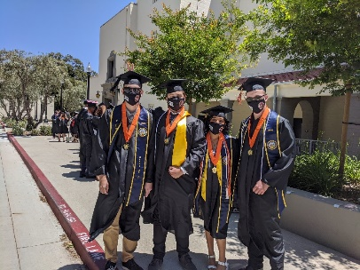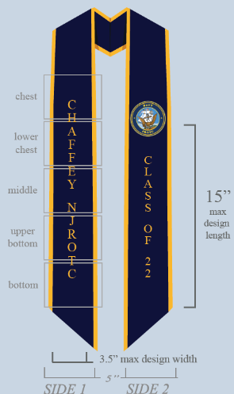**

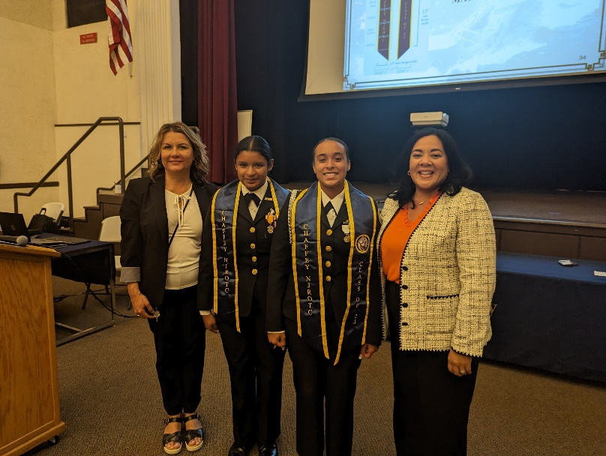**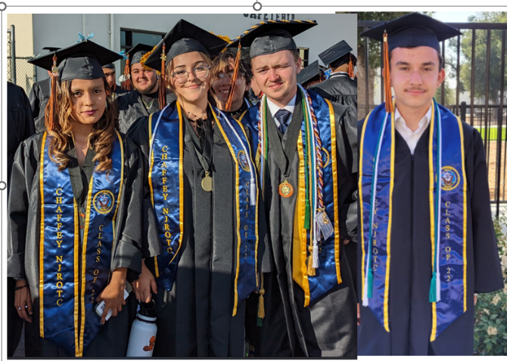**

**SECRET TO BEING A STRAIGHT “A” STUDENT**

1. **Set priorities** – Top students tolerate no intrusions on study time. Once the books are

open or the computer is booted up, phone calls go unanswered, TV shows unwatched,

snacks ignored. Study is work; work comes before play.

2. **Study anywhere – or everywhere**

* A cross-country runner, who worked out every day, used the time to memorize

biology terms

* A premed student posted a vocabulary list by the medicine cabinet so he could

learn a new word every day while brushing his teeth

Whenever or wherever you study, there is a need for consistency. Maintain a slot every

day for studying.

3. **Get organized** – Keep everything right where you can put your hands on it. Even

students who don’t have a private study area remain organized. A backpack or drawer

keeps essential supplies together and cuts down on time-wasting searches. Use of a

planner/organizer will help to keep track of all your class subjects and activities.

4. **Learn how to read** – The secret to good reading is to be an active reader – continually

ask questions that lead to a full understanding of the author’s message. Study in chunks.

Frequently summarize what you've just read. Make a list of Questions of textual material

that you don't understand, and ask the teacher at the next class.

5. **Schedule your time** – Successful students, when given a long paper, draw up a time-

table, dividing the project into small pieces so it isn’t so overwhelming.

* Even the best students will procrastinate sometimes, but, when that happens,

they face up to it and burn the midnight oil if necessary to ensure they meet

the deadline.

6. **Take good notes** – and use them. The teacher is going to test you on what he or she

emphasizes. That’s what you’ll find in your notes.

* The top students also take notes while reading the text assignment.
* More often than not, top students will take a minute or two at the end of the

class period to write a two- or three-sentence summary of the lesson’s

principal points which he or she wants to scan before the next day’s class.

7. **Clean up your act** – Neat papers are more likely to get higher grades than sloppy ones.

8. **Speak up** – Class participation goes beyond merely asking questions. It’s a matter of

showing intellectual curiosity.

* Better grades come from better understanding

9. **Study together** – By discussing homework problems together, you can try different

approaches and explain your solutions to one another.

10. **Test yourself** – Students who make up possible test questions often find many of the

same questions on the real exam and thus score higher.

11. **Do more than you’re asked** – Part of learning is practice. The more you practice,

the more you learn.

12. **Notes** - Review your notes frequently - at least weekly.

**A STUDY SYSTEM FOR A READING ASSIGNMENT**

1. **Scan or preview** section titles and the first sentences of paragraphs before reading the

chapter.

* Find the main topics and subtopics. These are usually given in capital letters

or italics at the beginning of each section.

2. **Question** what you are trying to find out. This can be helped by reading through the

questions at the end of the chapter. Also try thinking of questions as you preview the

section titles and topic sentences in Step 1.

* If you can think of questions while you preview, you will get a good idea of

what you should learn from the assignment.

3. **Read** the assignment carefully, and, as you do, think of your questions.

* Look for the main points as you go along; you are looking for answers to your

questions.

4. **Recall** and think about what you read after finishing the reading assignment. This can

be done by going through the questions and the vocabulary list at the end of each chapter.

* You must be able to pick out the main points from the reading assignment and

state or write the important sub points under them.

* You must be able to explain the major points *in your own words* and *understand*

what you are saying.

5. **Write** short answers to the questions at the end of the chapter in your spiral or loose-leaf

notebook. With a neatly kept notebook like this, you can make a quick review before

class and before tests or quizzes.

* Writing may be considered a part of the recall process, for it requires you to

remember answers.

6. **Review** your answers to the questions at the end of the chapter.

* Review may take place at any time.

\* \* \* \* \* \* \* \* \* \* \* \* \* \* \* \* \* \* \* \* \* \* \* \* \* \* \* \* \* \* \* \* \* \* \* \* \* \* \* \* \* \* \* \* \* \* \* \* \* \*

Keep in mind two things:

1. A study system must be used often in order to work; and

2. The “normal” or “natural” way of reading without a good study pattern will give you

poor results.

*NAVAL ACADEMY AND NAVY ROTC SCHOLARSHIPS*

For those who believe they are destined or called to serve as an officer in one of the branches of the US military, the key is to start early, take AP and Honor courses, earn a high Grade Point Average of at least 3.20 or higher, earn a class standing in the top 20%, if possible, be involved in varsity sports, become a leader in School Clubs, Scouts, JROTC, Civil Air Patrol, Police and Fire Explorers, Drama, Band, Orchestra, Choir, Renaissance, ASB, AVID, LINK Crew, or other Chaffey support groups, accrue community service and school service support hours, and apply for and receive a nomination from a Congressional Representative, Senator, Vice President or President. All these contribute towards a cadet’s possible appointment to one of the nation’s major military academies worth hundreds of thousands of dollars and commissioning as an officer in the military service.

Whether seeking to attend a major university ROTC program or seek a Naval Academy appointment, your focus needs to be on how many of the boxes you can check off in the charts below and on the following pages during your four years in high school.

Navy ROTC scholarships usually award between $200,000 and $220,000 over four years, and usually pay tuition, books, and a small monthly stipend. US Naval Academy appointments, usually are worth $450,000 to $550,000, depending on your major and years required to earn a specialized degree. This appointment includes tuition, room and board, books, medical, travel, lab fees, and a monthly stipend.

|  |  |  |  |  |  |  |  |  |  |  |  |  |  |  |  |  |  |  |  |  |
| --- | --- | --- | --- | --- | --- | --- | --- | --- | --- | --- | --- | --- | --- | --- | --- | --- | --- | --- | --- | --- |
| **ACTIVITY/GRADE** | **Jr. Varsity, American Legion, Babe Ruth, etc.**(not intramurals) | | | | **Varsity School Teams** | | | | **Varsity Letters Earned** | | | | **Team Captain OR**  **Co-Captain** | | | | **All State/ District/**  **City Or County** (1st Team only) (Explain in remarks) | | | |
| **A** | | | | **B** | | | | **C** | | | | **D** | | | | **E** | | | |
| **9** | **10** | **11** | **12** | **9** | **10** | **11** | **12** | **9** | **10** | **11** | **12** | **9** | **10** | **11** | **12** | **9** | **10** | **11** | **12** |
| **TEAM COACH, MANAGER OR TRAINER** |  |  |  |  |  |  |  |  |  |  |  |  |  |  |  |  |  |  |  |  |
| **BASEBALL/SOFTBALL** |  |  |  |  |  |  |  |  |  |  |  |  |  |  |  |  |  |  |  |  |
| **BASKETBALL** |  |  |  |  |  |  |  |  |  |  |  |  |  |  |  |  |  |  |  |  |
| **CREW/ROWING** |  |  |  |  |  |  |  |  |  |  |  |  |  |  |  |  |  |  |  |  |
| **CROSS COUNTRY** |  |  |  |  |  |  |  |  |  |  |  |  |  |  |  |  |  |  |  |  |
| **FOOTBALL/RUGBY** |  |  |  |  |  |  |  |  |  |  |  |  |  |  |  |  |  |  |  |  |
| **GOLF** |  |  |  |  |  |  |  |  |  |  |  |  |  |  |  |  |  |  |  |  |
| **GYMNASTICS/COMPETITIVE DANCE/CHEERLEADING** |  |  |  |  |  |  |  |  |  |  |  |  |  |  |  |  |  |  |  |  |
| **HOCKEY(FIELD OR ICE)** |  |  |  |  |  |  |  |  |  |  |  |  |  |  |  |  |  |  |  |  |
| **JUDO, KARATE OR OTHER MARTIAL ARTS** |  |  |  |  |  |  |  |  |  |  |  |  |  |  |  |  |  |  |  |  |
| **LACROSSE** |  |  |  |  |  |  |  |  |  |  |  |  |  |  |  |  |  |  |  |  |
| **RIFLE/PISTOL** |  |  |  |  |  |  |  |  |  |  |  |  |  |  |  |  |  |  |  |  |
| **SKIING** |  |  |  |  |  |  |  |  |  |  |  |  |  |  |  |  |  |  |  |  |
| **SOCCER** |  |  |  |  |  |  |  |  |  |  |  |  |  |  |  |  |  |  |  |  |
| **SWIMMING/DIVING** |  |  |  |  |  |  |  |  |  |  |  |  |  |  |  |  |  |  |  |  |
| **TENNIS** |  |  |  |  |  |  |  |  |  |  |  |  |  |  |  |  |  |  |  |  |
| **TRACK (Indoor/Outdoor)** |  |  |  |  |  |  |  |  |  |  |  |  |  |  |  |  |  |  |  |  |
| **VOLLEYBALL** |  |  |  |  |  |  |  |  |  |  |  |  |  |  |  |  |  |  |  |  |
| **WATER POLO** |  |  |  |  |  |  |  |  |  |  |  |  |  |  |  |  |  |  |  |  |
| **WEIGHTLIFTING/POWERLIFTING** |  |  |  |  |  |  |  |  |  |  |  |  |  |  |  |  |  |  |  |  |
| **WRESTLING** |  |  |  |  |  |  |  |  |  |  |  |  |  |  |  |  |  |  |  |  |

**NAVAL ACADEMY AND NAVY ROTC SCHOLARSHIPS** *(continued)*

|  |  |  |  |
| --- | --- | --- | --- |
| Boy Scouts of America (Remember, if you are an officer you are also a member) | ⬜ Member | ⬜ Eagle | ⬜ Sr. Patrol Leader |
| Girl Scouts of America | ⬜ Member | ⬜ Gold Award Recipient | ⬜ Troop Officer |
| Camp Fire Girls | ⬜ Horizon Club Member | ⬜ Camp Counselor | ⬜ Rep Regional Meetings |
| Rainbow Girls | ⬜ Member | ⬜ Officer | ⬜ Grand/Supreme Leader |
| Sea, Venture and Explorer Scouts | ⬜ Member | ⬜ Troop Officer | ⬜ Silver Awards |

|  |  |  |  |  |  |  |  |  |  |  |  |  |
| --- | --- | --- | --- | --- | --- | --- | --- | --- | --- | --- | --- | --- |
| **SCHOOL OFFICERS** | **STUDENT BODY/ COUNCIL / GOVERNMENT** | | | | **CLASS** | | | | **SCHOOL CLUB** | | | |
| **GRADE** | **9** | **10** | **11** | **12** | **9** | **10** | **11** | **12** | **9** | **10** | **11** | **12** |
| President/Chairperson |  |  |  |  |  |  |  |  |  |  |  |  |
| Vice President |  |  |  |  |  |  |  |  |  |  |  |  |
| Secretary/Treasurer |  |  |  |  |  |  |  |  |  |  |  |  |
| Representative/Committee Chairperson |  |  |  |  |  |  |  |  |  |  |  |  |

|  |  |  |  |  |
| --- | --- | --- | --- | --- |
| SCHOOL PUBLICATIONS |  |  |  |  |
| GRADE | 9 | 10 | 11 | 12 |
| Editor In Chief |  |  |  |  |
| Business Circulation or Advertising Manager |  |  |  |  |
| Feature, Sports, News, or Photo Editor |  |  |  |  |
| Writer-Reporter or other Staff Member |  |  |  |  |

|  |  |  |  |
| --- | --- | --- | --- |
| SCHOOL ORGANIZATIONS | | | |
| Boy's/Girl's Nation | President | Vice President | Delegate |
| Boy's/Girl's State | Governor | Lt. Governor | Delegate |
| National Honor Society | President | Vice President | Member |
| Beta Club | President | Vice President | Member |

|  |  |  |  |  |  |  |  |  |  |  |  |  |
| --- | --- | --- | --- | --- | --- | --- | --- | --- | --- | --- | --- | --- |
| SCHOOL BAND | Orchestra | | | | Chorus | | | | Band | | | |
| Grade | 9 | 10 | 11 | 12 | 9 | 10 | 11 | 12 | 9 | 10 | 11 | 12 |
| Director, Leader, or Drum Major |  |  |  |  |  |  |  |  |  |  |  |  |
| Member |  |  |  |  |  |  |  |  |  |  |  |  |

**NAVAL ACADEMY AND NAVY ROTC SCHOLARSHIPS** *(continued)*

|  |  |  |  |  |  |  |
| --- | --- | --- | --- | --- | --- | --- |
| **OTHER ACTIVITIES INCLUDING JROTC AND CIVIL AIR PATROL** | **9** | **10** | | **11** | | **12** |
| Participation in Competitive, Dramatic, or Humorous Reading |  |  | |  | |  |
| Participation in contest one-act plays |  |  | |  | |  |
| Participation as an actor/actress, stage manager, or student  director in a 3 act play before a public audience |  |  | |  | |  |
| Drill Team/ Color Guard |  |  | |  | |  |
| Cheerleader/ Pom Pom |  |  | |  | |  |
| 4H Club Judge |  |  | |  | |  |
| 4H Club Member |  |  | |  | |  |
| DECA |  |  | |  | |  |
| Active member of Sailing Association |  |  | |  | |  |
| Sea Cadet Member |  |  | |  | |  |
| JROTC / CAP Member (High School Only) |  |  | |  | |  |
| JROTC/Sea Cadet / Civil Air Patrol |  |  | |  | |  |
| If in JROTC or CAP, which branch? | NAVY | | MARINE | | ARMY | |
| AIR FORCE | | CAP | | COAST GUARD | |
| Junior Achievement | President | | Vice President | | Member | |
| Church Group | President | | Vice President | | Member | |

Students must devote all four years in high school toward achieving their best performance in many different areas in order to be seen as competitive. Three former Chaffey NJROTC Tigers, just like you, received a Naval Academy appointment, and two of them have now graduated. ***You can too***.

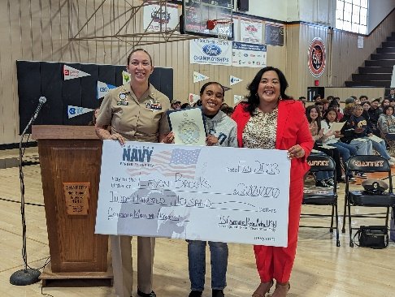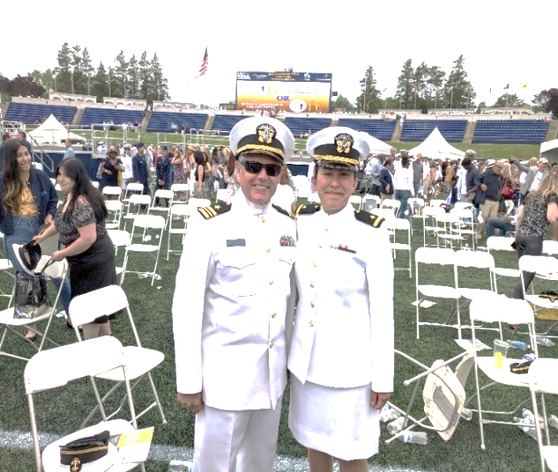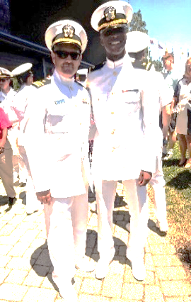

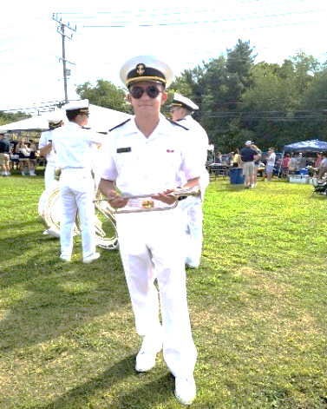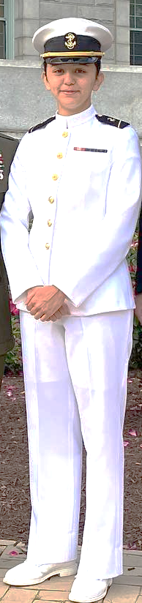

**LEYONI BROOKS**

**Midshipman**

**University of California**

**San Diego**

**Navy ROTC**

**Chaffey Class of 2023**

**Projected Graduation**

**2027**

**JENNY INIGUEZ**

**LTJG, US NAVY**

**Chaffey Class of 2015**

**Graduated USNA 2021**

**BS Electrical Engineering**

**Naval Flight Officer**

**Pensacola, FL**

**JOSHUA REYES**

**Chaffey Class of 2019**

**JESSICA FELIX**

**Midshipman 3rd Class**

**Chaffey Class of 2019**

**Graduate of NAPS 2020**

**Projected**

**USNA Graduate 2026**

**JONATHAN SCHULER**

**Midshipman 4th Class**

**Chaffey Class of 2022**

**JELANI WILLIAMS**

**LT, US NAVY**

**Chaffey Class of 2015**

**Graduated USNA 2019**

**BS Computer Science**

**Surface Officer**

**USS America (LHA-6)**

**Sasebo, Japan**

For those who would like more information on either the US Naval Academy or the Navy’s University Level ROTC Programs, please review the next couple of pages. Hopefully you can make a determination whether this is for you or not. Feel free to contact LCDR Martin Jones.

**UNITED STATES NAVAL ACADEMY**

**GENERAL ADVICE FOR GRADES 9-12**

**9th Grade**

Although it is too early for you to apply, it is not too early to prepare. By starting now, you will get a head start on making yourself a competitive candidate. The key to candidacy at the Academy is simple: achieve good grades in challenging college prep courses, hone your competitive spirit by participating in athletics, and practice your leadership skills in clubs and serving your community. For now, please have a look at our [STEM Website](https://www.usna.edu/Admissions/Programs/STEM.php), which provides information regarding the Naval Academy Science, Technology, Engineering, and Math camp. You may apply for STEM as a rising 8th, 9th, 10th, or 11th graders. We recommend that you apply for this wonderful opportunity to see the Naval Academy and explore the world of STEM!

**﻿10th Grade**

If you are in 10th grade, you should continue focusing on your academics, extracurricular activities, leadership roles and taking the PSAT. 10th grades also have the ability to apply for [Summer STEM](https://www.usna.edu/Admissions/Programs/STEM.php). When planning your high school curriculum, you should keep the following suggestions in mind:

To improve your chances of board qualification, your high school preparation should include the following:

* **Mathematics**- four years of mathematics courses, including a strong foundation in geometry, algebra, and trigonometry. Courses in pre-calculus and calculus are also very valuable and are highly encouraged.
* **Science**- one year each of chemistry and physics, with lab if possible.
* **English**- four years of coursework with special attention to the study and practice of effective writing. Surveys of English and American literature are especially helpful as background for the future study of literature.

To further enhance your competitiveness for admission, the following courses are also recommended:

* **Foreign language** - at least two years.
* **History**- one full year of U.S. history and, where possible, a full year of European or world history.
* **Introductory computer and typing courses** are recommended because all midshipmen are required to use personal computers in most courses.

We recommend **Honors, Advanced Placement, and International Baccalaureate courses** if offered.

**11th Grade**

Please keep the following timeline in mind if you are currently in 11th grade:

**Starting in December of your junior year (if not sooner):** Take the ACT and SAT exams early and often. If you do not score well on one, take the other. The Naval Academy combines the highest math and verbal scores from either test to evaluate your competitiveness. Results are accepted as late as February of your application year.

* **January-March of your junior year:** Complete a USNA Summer Seminar [application](https://www.usna.edu/Admissions/Programs/STEM.php). This application also serves as the preliminary application so there is no need to submit another one.
* **April of your junior year:** Complete a [preliminary application](https://candidateinformation.usna.edu/ITSD/pcq/acawu013$.startup) (if you did not apply to Summer Seminar). If you meet the minimum academic standards, you will be notified that you are an official candidate and you will be given instructions on how to complete the remainder of your online application.
* **Spring of your junior year:** Begin contacting the offices of your Representative and both of your US Senators to request a nomination. Many Congressional members set an early fall deadline for nomination requests. Check their websites to determine their procedures.
* **June of your junior year to February of your senior year:** Complete your [online application](https://candidateinformation.usna.edu/ITSD/pcq/acawu013$.startup), [medical examination](https://dodmerb.tricare.osd.mil/), and [Candidate Fitness Assessment](https://www.usna.edu/Admissions/Candidate-Fitness-Assessment.php).

**﻿12th Grade**

If you have already entered 12th grade, please complete a [preliminary application](https://www.usna.edu/Admissions/Apply/index.php) as soon as possible. If you meet the minimum academic standards, you will be notified that you are an official candidate and you will be given instructions on how to complete the remainder of your online application. You should be sure to manage your application carefully, paying special attention to deadlines for your individual congressional nominations. We also suggest that you read our [FAQs page](https://www.usna.edu/FAQ) and try to learn more about [life at USNA](https://www.usna.edu/Admissions/Student-Life/index.php) to make the most informed college decision possible. If you believe USNA is for you, begin preparing yourself physically for the challenges of [Plebe Summer](https://www.usna.edu/Admissions/Student-Life/Plebe-Summer.php) and [apply now](https://www.usna.edu/Admissions/Apply/index.php)!

#### **ELIGIBILITY**

You are eligible to apply for the United States Naval Academy if you meet the following criteria:

* A United States Citizen
* Ages 17 – 23 (on July 1 of the year of entry)
* Unmarried
* Not pregnant and no dependents
* Have a valid Social Security Number (If you do not have a Social Security number you can apply for a card here [https://www.ssa.gov](https://www.ssa.gov/))

If you are in high school but are not old enough to apply, you can register with USNA to receive information about our [Summer Programs](https://www.usna.edu/Admissions/Programs/index.php).

If you are interested in attending college with either a Navy ROTC scholarship or through the US naval Academy, and then serving as an officer in the military, please speak with LCDR Jones. However, keep in mind that we want you to follow whatever career you desire, civilian or military, and whenever possible we want you to go to college.

CHAFFEY HIGH NAVY JROTC COMMAND STAFF POSITIONS

***(Where Do I Fit in?)***

VICE PRESIDENT OF THE US

KAMALA HARRIS

PRESIDENT OF THE US

JOSEPH BIDEN

CHAFFEY HIGH NAVY JROTC C/COMMANDING OFFICER ***(YOU - RED)***

***(CADETS – BLUE)***

NAVY SCIENCE INSTRUCTOR

SHCM (E9) (SW/AW) HECTOR RAZO, USN (RET)

SENIOR NAVY SCIENCEINSTRUCTOR

LCDR MARTIN JONES, USN (RET)

GOVERNOR CALIFORNIA

MR. GAVIN NEWSOM

SECNAV

HONORABLE CARLOS DEL TORO

CHIEF NAVAL OPERATION

ADM MICHAEL GILDAY, USN

ASST PRINCIPAL

MR. TREVOR WOOLERY

PRINCIPAL

MRS. CHRISTINA MARTINEZ

SUPERINTENDENT

DR. MAT HOLTON

SUPERINTENDENT OF SCHOOLS SAN BERNARDINO COUNTY

MR. TED ALEJANDRE (LTCOL USAF RESERVES)

SECDEF

HONORABLE LLOYD AUSTIN

CHAFFEY BOARD OF TRUSTEES

MRS. SUE OVITT, MR. GIL ZENDEJAS, MRS. SHARI MEGAW, MR. DONALD ENGLISH

MR. ART BUSTAMANTE,

CNET

RADM [JEFFREY CZEREWKO](http://www.netc.navy.mil/Who-We-Are/NETC-Leadership/NETC-Leadership-Display/Article/3422621/rear-admiral-jeffrey-czerewko/), USN

NSTC

RADM CRAIG T. MATTINGLY, USN

AREA MANAGER

CDR THOMAS GARCIA, USN (RET)

**WE SERVE!**

**CHAFFEY STAKEHOLDERS**



PARENTS, GUARDIANS, COMMUNITY



TEACHERS



COUNSELORS



COACHES



MIDDLE / ELEMENTARY SCHOOLS



MUSEUM, PARKS



OTHER NJROTC



CHAFFEY CLUBS



CHAFFEY

SPORTS



CHAFFEY

BAND/DANCE/CHOIR



CITY COUNCILS / MAYORS

**THE 24-HOUR CLOCK**

**Time shown here is 0225 (if in the morning) or 1425 (if in the afternoon).**

**2400**

**1300**

**2300**

**1200**

**1100**

**0100**

**2200**

**1400**

**1000**

**0200**

**1500**

**0300**

**2100**

**0900**

**0400**

**2000**

**0800**

**1600**

**0500**

**0700**

**0600**

**1700**

**1900**

**1800**

**PHONETIC ALPHABET**

**A – ALPHA (AL-FAH) N – NOVEMBER (NO-VEM-BER)**

**B – BRAVO (BRAH-VOH) O – OSCAR (OSS-CAH)**

**C – CHARLIE (CHAR-LEE) P – PAPA (PAH-PAH)**

**D – DELTA (DELL-TAH) Q – QUEBEC (KEH-BECK)**

**E – ECHO (ECK-OH) R – ROMEO (ROW-ME-OH)**

**F – FOXTROT (FOKS-TROT) S – SIERRA (SEE-AIR-RAH)**

**G – GOLF (GOLF) T – TANGO (TANG –GO)**

**H – HOTEL (HOH-TELL) U – UNIFORM (YOU-NEE-FORM)**

**I – INDIA (IN-DEE-AH) V – VICTOR (VIK-TAH)**

**J – JULIETT (JEW-LEE-ETT) W – WHISKEY (WISS-KEY)**

**K – KILO (KEY-LOH) X – X-RAY (ECKS-RAY)**

**L – LIMA (LEE-MAH) Y – YANKEE (YANG-KEE)**

**M – MIKE (MIKE) Z – ZULU (ZOO-LOO)**

NAVY SIGNAL FLAGS, MORSE CODES AND SEMAPHORE SIGNALS

|  |  |  |  |  |  |  |
| --- | --- | --- | --- | --- | --- | --- |
| **ALPHA** | **BRAVO** | **CHARLIE** | **DELTA** | **ECHO** | **FOXTROT** | **GOLF** |
| Letter A Signal Flag | Letter B Signal Flag | Letter C Signal Flag | Letter D Signal Flag | Letter E Signal Flag | Letter F Signal Flag | Letter G Signal Flag |
| **•˗** | **˗•••** | **˗•˗•** | **˗••** | **•** | **••˗•** | **˗˗•** |
| visual_flag_signals_semaphore.jpg | visual_flag_signals_semaphore.jpg | visual_flag_signals_semaphore.jpg | visual_flag_signals_semaphore.jpg | visual_flag_signals_semaphore.jpg | visual_flag_signals_semaphore.jpg | visual_flag_signals_semaphore.jpg |
|  |  |  |  |  |  |  |
| **HOTEL** | **INDIA** | **JULIET** | **KILO** | **LIMA** | **MIKE** | **NOVEMBER** |
| Letter H Signal Flag | Letter I Signal Flag | Letter J Signal Flag | Letter K Signal Flag | Letter L Signal Flag | Letter M Signal Flag | Letter N Signal Flag |
| **••••** | **••** | **•˗˗˗** | **˗•˗** | **•˗••** | **˗˗** | **˗•** |
| visual_flag_signals_semaphore.jpg | visual_flag_signals_semaphore.jpg | visual_flag_signals_semaphore.jpg | visual_flag_signals_semaphore.jpg | visual_flag_signals_semaphore.jpg | visual_flag_signals_semaphore.jpg | visual_flag_signals_semaphore.jpg |
|  |  |  |  |  |  |  |
| **OSCAR** | **PAPA** | **QUEBEC** | **ROMEO** | **SIERRA** | **TANGO** | **UNIFORM** |
| Letter O Signal Flag | Letter P Signal Flag | Letter Q Signal Flag | Letter R Signal Flag | Letter S Signal Flag | Letter T Signal Flag | Letter U Signal Flag |
| **˗˗˗** | **•˗˗•** | **˗˗•˗** | **•˗•** | **•••** | **˗** | **••˗** |
| visual_flag_signals_semaphore.jpg | visual_flag_signals_semaphore.jpg | visual_flag_signals_semaphore.jpg | visual_flag_signals_semaphore.jpg | visual_flag_signals_semaphore.jpg | visual_flag_signals_semaphore.jpg | visual_flag_signals_semaphore.jpg |
|  |  |  |  |  |  |  |
| VICTOR | WHISKEY | XRAY | YANKEE | ZEBRA |  |  |
| Letter V Signal Flag | Letter W Signal Flag | Letter X Signal Flag | Letter Y Signal Flag | Letter Z Signal Flag |  |  |
| **•••˗** | **•˗˗** | **˗••˗** | **˗•˗˗** | **˗˗••** |  |  |
| visual_flag_signals_semaphore.jpg | visual_flag_signals_semaphore.jpg | visual_flag_signals_semaphore.jpg | visual_flag_signals_semaphore.jpg | visual_flag_signals_semaphore.jpg |  |  |

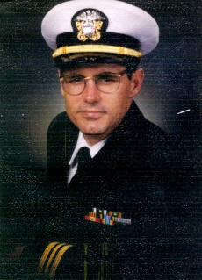

**LIEUTENANT COMMANDER MARTIN A. JONES, USN (RET.)**

**Senior Naval Science Instructor**

LCDR Jones was born in Detroit, Michigan. When five years old, LCDR Jones’ family moved from Detroit, Michigan to San Diego, CA, where he spent most of his youth. During his high school years, he served four years in an Army JROTC unit at Madison High School, in San Diego, CA, working with the Air Rifle Marksmanship team, the Armed Drill Team and the Drum and Bugle Team.

Graduating high school in 1973, LCDR Jones joined the US Air Force and served as a weapons control specialist in electronic and mechanical aircraft systems. He was stationed at Lackland AFB (San Antonio, TX), Lowry AFB (Denver, CO), Luke AFB (Phoenix, AZ) and Clark AFB (Republic of the Philippines) until 1979.

During his Air Force Career from 1973 to 1979, (then) SGT Jones worked on the following aircraft:

F-4 Phantoms F-15 Eagle F-111 Aardvarks B-52 Stratofortress

During his time in the Philippines, LCDR Jones began attending college on the GI Bill. He completed his Bachelor of Science degree in Business Management (with an emphasis in Quantitative Analysis) and a minor in Economics, graduating in 1982 and applied to become a US Naval Officer through Officer Candidate School (OCS) in Newport, RI. LCDR Jones attended OCS and in January, 1983 was commissioned by the President of the United States as an Ensign in the US Navy in June, 1983. After ten years, LCDR Jones applied for and was accepted to the Navy’s Postgraduate School in Monterey, CA, where he earned his Master of Science in Logistics Management in 1993.

During his Navy career LCDR Jones worked on the following aircraft and served on the following Navy Ships and Navy stations, in support of both carrier and destroyer groups, amphibious groups, Marine Expeditionary Units (MEU 11 and 31) and served at naval Air Systems Command, Washington DC on the V-22 Osprey program during its Full-Scale Development from 1987 to 1989.

AIRCRAFT:

F-14 Tomcats F-18 Hornets AV-8B Harriers V-22 Ospreys

AH-1W Cobras UH-1N Hueys CH-46 CH-53

SHIPS:

USS Tripoli, (LPH-10) USS Carl Vinson (CVN-70) USS Tarawa (LHA-1)

NAVY STATIONS

Naval Station Providence, Rhode Island Navy Supply Corps School, Athens, GA

32nd St Naval Station, San Diego, CA Aviation Maintenance Officer School, Pensacola, FL

Naval Air Systems, Washington DC Naval Air Station Miramar, San Diego

Fighter Squadron 111 (Sundowners), San Diego, CA Navy Postgraduate School, Monterey, CA

Naval Air Station Lemoore, Lemoore, CA 32nd St Naval Station, San Diego, CA (Final)

During his 23-year military career LCDR Jones deployed to the Persian Gulf and Red Sea three times, sailing through the Indian, Pacific and Atlantic Oceans. Places he visited include Hawaii, Guam, Japan, Hong Kong, Singapore, Malaysia, Australia, Korea, Vietnam, Sri Lanka, Diego Garcia, Kuwait, Bahrain, Iraq, Jebel Ali, Qatar, Eritrea (Africa), Aquaba (Jordan), Israel, and Alaska. After retiring from the US Navy, LCDR Jones served as a Manager for an international company, employing 800 personnel, serving thousands of customers world-wide with travel needs. LCDR Jones became a Navy JROTC Teacher in 2003. He has worked in Lancaster, CA, Fallon, NV, Corona, CA and now Chaffey HS. He has been at Chaffey since 2013.

He serves as one of the US Naval Academy Admission Advisors (Blue and Gold Officer), and serves students in 19 high schools from La Verne to Rialto, CA in San Bernardino County, all eight high schools in the Chaffey Joint Union HS District Upland HS, Ontario Christian, Western Christian, and United Christian High Schools. LCDR Jones has been married for 45 years to Elizabeth J. Valdez. They enjoy their three children and five grandchildren, travelling, camping, hiking, and great food. They reside in Etiwanda (Rancho Cucamonga), CA.

**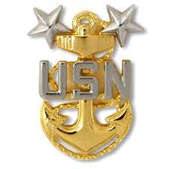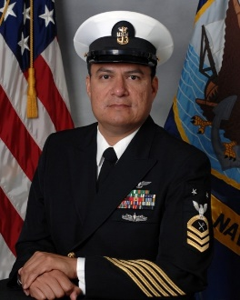MASTER CHIEF HECTOR RAZO (SHCM /AW/SW), US NAVY (RET)**

**Naval Science Instructor**

Master Chief Razo was born in Mexico and raised in Rio Grande City, Texas. He graduated from Rio Grande City High School on May 1987. He served in the United States Navy from September 9, 1987 to September 30, 2017.

He served onboard five ships. These include:

USS BELKNAP (CG 26), homeported in Gaeta, Italy,

USS CARL VINSON (CVN 70), in Bremerton, Washington,

USS FIFE (DD 991), in Yokosuka, Japan,

USS MCCLUSKY (FFG 41), where he was MCCLUSKY’s 2000 Sailor of the Year!

USS RONALD REAGAN (CVN 76), and

USS CARL VINSON (CVN 70) homeported in San Diego, CA.

Ashore, Master Chief Razo served at the following shore commands:

Defense Commissary Agency, Kingsville, TX, as an instructor;

Fleet Training Center, San Diego, as Force Ship’s Serviceman at Commander, Naval Surface Forces, Pacific Fleet in Coronado, and

Naval Medical Center San

Diego Senior Enlisted Leader of the Directorate for Administration as the Senior Enlisted Leader

.

During Master Chief Razo’s 30-year naval career he received awards which included the Meritorious Service Medal, Navy Commendation Medal, the Navy Achievement Medal, the Military Outstanding Volunteer Service Medal and various campaign and unit awards. He was certified as both a Master Training Specialist and an Afloat Training Specialist.

While on active duty service, he earned an Associate Degree in General Studies from Central Texas College, a Bachelor of Science Degree in Workforce Education from Southern Illinois University, a Bachelor of Arts Degree in History from National University and a Master of

Science Degree in Education from Southern Illinois University. He resides with his wife Marina in Murrieta, California.

NOTES:

|  |
| --- |
|  |
|  |
|  |
|  |
|  |
|  |
|  |
|  |
|  |
|  |
|  |
|  |
|  |
|  |
|  |
|  |
|  |
|  |
|  |
|  |