NAVY JROTC END OF YEAR AWARD MEDALS

At the end of the year, Chaffey High School Navy JROTC invites a number of distinguished organizations to attend their annual award ceremony. These organizations are usually associated with various Fraternal Veteran Groups from across the nation, and take great pleasure in recognizing and awarding OUTSTANDING service, Academic Achievement, and Team Spirit.

Cadets desiring to receive one or more of these medal awards must strive to consistently perform at a much higher level than most cadets in the Navy’s JROTC program. Specific criteria for being nominated for one of these awards are below:

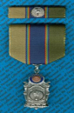 | AMERICAN LEGION  MILITARY APTITUDE | Presented to one NS2/3/4 who: A. Ranks in the top 25% of their Naval Science Class; B. Demonstrates outstanding qualities of Leadership and Outstanding Uniform wear;  C. Always gets involved, sets the example for others to follow in areas of community service, academics, drill, physical fitness, and school service. D. Demonstrates outstanding moral character and citizenship.
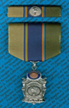 | AMERICAN LEGION  SCHOLASTIC  APTITUDE | Presented to one NS2/3/4 who: A. Ranks in the top 10% of their Naval Science Class; B. Demonstrates outstanding uniform wear;  C. Always gets involved in community service, academics, drill, physical fitness, and school service. D. Maintains a GPA of 3.50 or higher in all classes for the year; E. Gets involved in at least 1 school Club and/or sport for the year; F. Demonstrates outstanding moral character and citizenship.
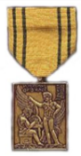 | ORDER OF  DAEDALIANS | The Order of Daedalians, the National Fraternity of Commissioned Military Pilots, is presented to one Junior which demonstrated: A. Patriotism, love of country, and service to our nation; B. Has indicated the potential and desire to pursue a military career; C. Ranks in the upper 10% of their JROTC class;  D. Earned an Overall GPA of 3.25 or higher for the year; E. Got involved in the unit and set a positive example; F. Ranks in the top 20% of their high school class.
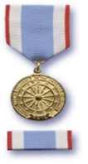 | DAUGHTERS OF THE AMERICAN REVOLUTION  AWARD | Be a Senior in the NJROTC program with two or more years, who; A. Is in the top 25% percent of their Senior class in all subjects, including NJROTC; B. Demonstrated qualities of dependability, good moral character, and reliably supported unit and school functions, good attendance and had no discipline; C. Demonstrated adherence to military discipline, including consistent decorum, respect for authority, respect for the Flag and the US Constitution, and respect for the uniform; D. Strong leadership ability, including providing consistent encouragement and motivation to junior cadets to do their best and to improve, and; E. Consistently reflected a fundamental and patriotic understanding of the importance of JROTC training
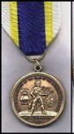 | SONS OF THE AMERICAN REVOLUTION  AWARD | Presented to an outstanding NS2/3/4 who: A. Demonstrated a high degree of leadership qualities, an overall GPA of 2.50 all classes, involved with school clubs and/or sports, community service; B. Strong military bearing, including proud, consistent wearing of the uniform, respect towards the constitution and the American Flag, and excellent military bearing and decorum at all times; C. General excellence in attitude and support towards the JROTC program, the instructors, good manners, punctuality, and support of school policies.
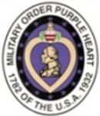 | ORDER OF  THE PURPLE HEART | Presented to an outstanding NS2/3/4 who: A. Has a positive attitude toward JROTC and country; B. Holds a leadership position in JROTC; C. Is highly active in school and community affairs; D. Has earned an overall GPA of 3.00 or higher in ALL subjects for the previous semester;
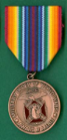 | MILITARY  ORDER OF  WORLD WARS  (MOWW) | This award is to be presented to an NS-I cadet who; A. Excels in all military and scholastic aspects; B. Maintains the highest military decorum, personal discipline, and overall GPA of 3.00 or above in all subjects; C. Involved in extracurricular activities, including sports and community service, and individual endeavors, including outside organization involvement, a desire to serve our nation. ; D. Has committed to continue the Nautical Science program for the next school year.
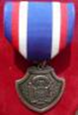 | MILITARY  OFFICERS ASSOCIATION OF AMERICA  (MOAA) | This award is to be presented to a Junior (11th Grade) cadet with 2 or more years who; A. Demonstrates outstanding moral character, strong citizenship; Teamwork, and a Positive “Can-Do” attitude; B. Maintained an overall GPA of 2.25 or higher C. Demonstrates a high order of loyalty to their unit, school and country, always trying to improve the unit, and D. Demonstrates exceptional potential for military leadership (fair, leads by example, helps others, strong community service).
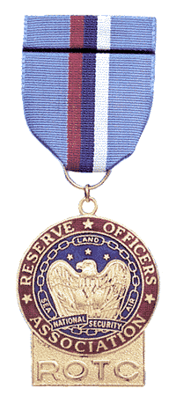 | RESERVE  OFFICERS ASSOCIATION  (ROA)  AWARD | Cadets who may receive this award must: A. Demonstrates a positive attitude toward the Naval Science curriculum; B. Exhibits excellent personal appearance (consistent, professional wear of the uniform, posture, and grooming); C. possesses exceptional personal attributes (initiative, judgment, and self-confidence); D. displays courtesy (punctuality to class, promptness, obedience, and respect); E. have strong growth potential (capacity for responsibility, high productivity, adaptability to change, maintenance of the highest personal and ethical standards, and strong positive convictions
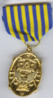 | NATIONAL  SOJOURNERS | Outstanding NS1/2/3 who A. Ranks in the top 25% of all their academic classes achieving a 2.50 overall GPA (B+) in all classes; B. Encourages and demonstrates ideals of Americanism both within the NJROTC CORPS and on campus; C. Demonstrates potential for outstanding leadership
 | STEPHEN DECATUR  1ST YEAR  AWARD | Possess a character reflecting the Navy's core values of Honor, Courage and Commitment, and who A. Demonstrates leadership potential; B. Demonstrates an aptitude in NJROTC as evidenced by motivation; C. Performance of duty and military bearing; D. Receives a "B" or better in NJROTC during the current year and also; E. Has a minimum of a cumulative "B" average in academic studies.
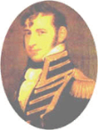 | STEPHEN DECATUR  3rd YEAR  AWARD | Has been in the program 3 years and possesses a character reflecting the Navy's core values of Honor, Courage and Commitment, and who  A. Demonstrates leadership potential; B. Demonstrates an aptitude in NJROTC as evidenced by motivation; C. Performance of duty and military bearing; D. Receives a "B" or better in NJROTC during the current year and also; E. Has a minimum of a cumulative "B" average in academic studies.
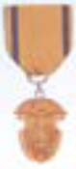 | VETERANS  OF  FOREIGN  WARS  AWARD | Presented to an outstanding NS3/4 with two or more years who: A. Attains a grade of "B" (3.00 or higher) GPA is all subjects; B. Has a positive attitude towards NJROTC; C. Has outstanding military bearing and conduct; D. Possesses strong positive personal attributes such as courtesy, dependability, punctuality, respect, and cooperation); E. Demonstrates patriotism (such as being a member of the color guard or drill team) and actively promotes Americanism; F. Demonstrates leadership potential; F. Active in student clubs/sports

