F-35C LIGHTNING (CARRIER VERSION)

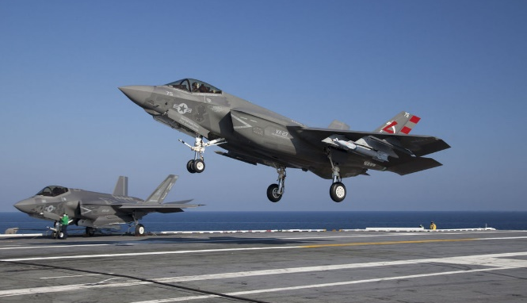
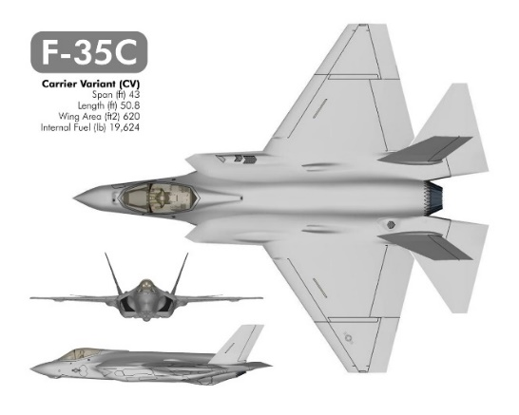

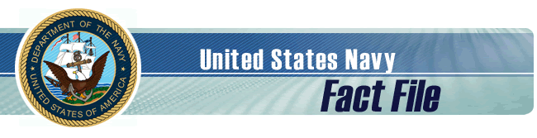

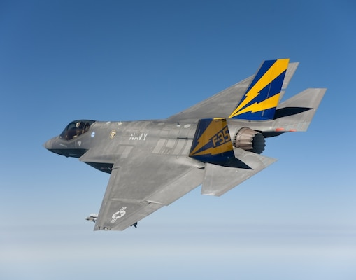
Description
The 5th generation F-35 Lightning II integrates advanced stealth technology into a highly agile, supersonic aircraft that provides the pilot with unprecedented situational awareness and unmatched lethality and survivability. As new threats emerge, it is more important than ever for U.S. and allied fighter fleets to fly the F-35 stealth fighter, the world's only 5th generation international aircraft. While each aircraft is uniquely designed to operate from different environments, all three variants set new standards in network-enabled mission systems, sensor fusion and supportability. The F-35 redefines the multirole fighter. Features
The F-35 is designed with the entire battlespace in mind, bringing transformational capability to the United States and its allies. Missions traditionally performed by specialized aircraft (air-to-air combat, air-to-ground strikes, electronic attack, intelligence, surveillance and reconnaissance) can now be executed by a squadron of F-35s.
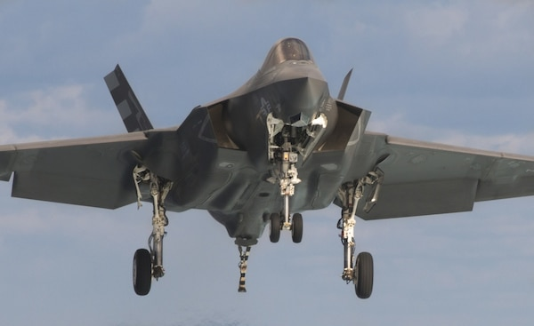
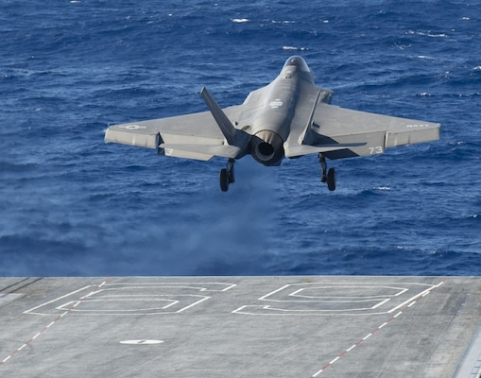

Background
For the first time in U.S. naval aviation history, radar-evading stealth capability comes to the carrier deck. The F-35C carrier variant sets new standards in weapon system integration, lethality, maintainability, combat radius and payload that bring true multimission power projection capability from the sea.
The F-35C combines lessons learned from previous aircraft with technology breakthroughs to produce a fighter that retains its stealthy advantage with minimal low observable maintenance, even in the harshest shipboard conditions.
The F-35C matches 5th generation survivability with major advances in network-enabled mission systems, reliability and interoperability. It is a first-day-of-the-war fighter with the capability to dominate adversaries in the air or on the surface, while surviving the most formidable threat environments. Service
Navy
General Characteristics
Primary Function: As threats around the world advance and legacy aircraft continue to age, the F-35 Lightning II is absolutely critical to ensuring the United States and our allies are operating the most powerful and effective aircraft in the world, no matter the enemy.
Contractor: Primary: Lockheed Martin
Northrop Grumman and BAE Systems
Unit Cost: $94.4M for LRIP 14
Propulsion: F135-PW-100
Length: 51.5 ft / 15.7 m
Height: 14.7 ft / 4.48 m
Wingspan: 43 ft / 13.1 m
Weight: 70,000 lb
Airspeed: Mach 1.6
Range: >1,200 n.mi / 2,200 km
Crew: 1
Load: 18,000 lb / 8,160 kg
Armament: AIM-120C/D, GBU-31 JDAM, AIM-9X, GBU-12 LGB and AGM-154 JSOW

F/A-18C/D HORNET AND F/A-18E/F SUPER HORNET
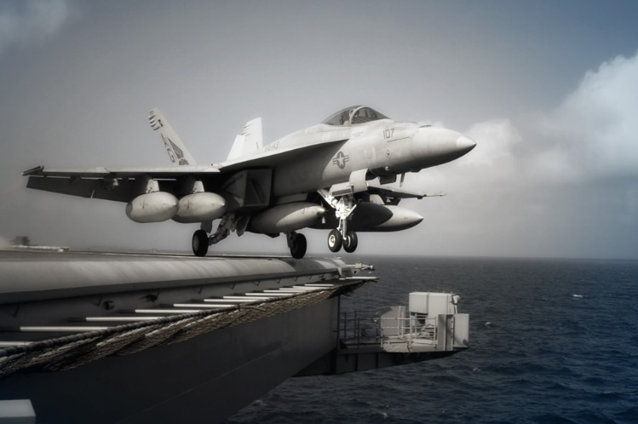
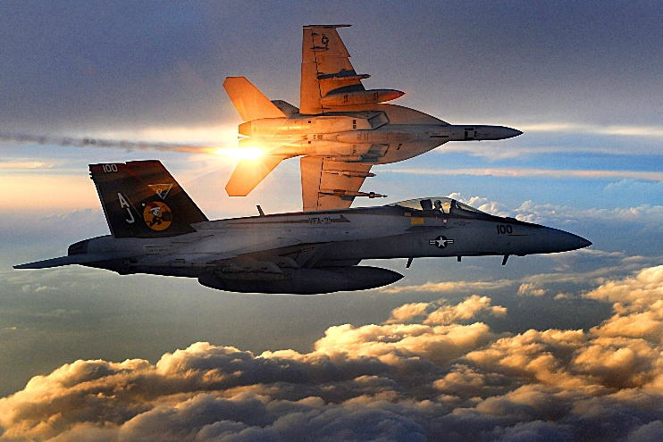

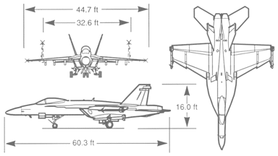
Agile, versatile and lethal, multi-mission Hornets are the quick-striking, high-tech hunters of an air wing.

Capable of taking out targets in all weather, night or day, surface or sky, many experts consider them to be the best class of fighter in the world. Hornet fighter/attack jets are the icons of Navy aviation.
.

F/A-18 HORNET STRIKE FIGHTER

Description
All-weather fighter and attack aircraft. The single-seat F/A-18 Hornet is the nation's first strike-fighter. It was designed for traditional strike applications such as interdiction and close air support without compromising its fighter capabilities. With its excellent fighter and self-defense capabilities, the F/A-18 at the same time increases strike mission survivability and supplements the F-14 Tomcat in fleet air defense. F/A-18 Hornets are currently operating in 37 tactical squadrons from air stations world-wide, and from 10 aircraft carriers. The U.S. Navy's Blue Angels Flight Demonstration Squadron proudly flies them. The Hornet comprises the aviation strike force for seven foreign customers including Canada, Australia, Finland, Kuwait, Malaysia, Spain and Switzerland.
The newest model, Super Hornet, is highly capable across the full mission spectrum: air superiority, fighter escort, reconnaissance, aerial refueling, close air support, air defense suppression and day/night precision strike. Compared to the original F/A-18 A through D models, Super Hornet has longer range, an aerial refueling capability, increased survivability/lethality and improved carrier suitability. [Capability of precision-guided munitions: JDAM (all variants) and JSOW. JASSM in the future]

Features
The F/A-18 Hornet, an all-weather aircraft, is used as an attack aircraft as well as a fighter. In its fighter mode, the F/A-18 is used primarily as a fighter escort and for fleet air defense; in its attack mode, it is used for force projection, interdiction and close and deep air support.

The F/A-18A and C are single seat aircraft. The F/A-18B and D are dual-seaters. The B model is used primarily for training, while the D model is the current Navy aircraft for attack, tactical air control, forward air control and reconnaissance squadrons. The newest models, the E and F were rolled out at McDonnell Douglas Sept. 17, 1995. The E is a single seat while the F is a two-seater.
Super Hornet, flew combat sorties from Abraham Lincoln during Southern Watch, demonstrating reliability and an increased range and payload capability. VFA 115 embarked aboard Lincoln expended twice the amount of bombs as other squadrons in their airwing (with 100% accuracy) and met and exceeded all readiness requirements while on deployment. The Super Hornet cost per flight hour is 40% of the F-14 Tomcat and requires 75% less labor hours per flight hour.
Service
Navy and Marine Corps

General Characteristics, Super Hornet, E and F models
Primary Function: Multi-role attack and fighter aircraft.
Contractor: McDonnell Douglas.
Date Deployed: First flight in November 1995. Initial Operational Capability (IOC) in September 2001 with VFA-115, NAS Lemoore, Calif.
Unit Cost: $57 million
Propulsion: Two F414-GE-400 turbofan engines. 22,000 pounds (9,977 kg) static thrust per engine.
Length: 60.3 feet (18.5 meters).
Height: 16 feet (4.87 meters).
Wingspan: 44.9 feet (13.68 meters).
Weight: Maximum Take Off Gross Weight is 66,000 pounds (29,932 kg).
Airspeed: Mach 1.8+.
Ceiling: 50,000+ feet.
Range: Combat: 1,275 nautical miles (2,346 kilometers), clean plus two AIM-9s
Ferry: 1,660 nautical miles (3,054 kilometers), two AIM-9s, three 480 gallon tanks retained.
Crew: A, C and E models: One B, D and F models: Two.
Armament: One M61A1/A2 Vulcan 20mm cannon; AIM 9 Sidewinder, AIM-9X (projected), AIM 7 Sparrow, AIM-120 AMRAAM, Harpoon, Harm, SLAM, SLAM-ER (projected), Maverick missiles; Joint Stand-Off Weapon (JSOW); Joint Direct Attack Munition (JDAM); Data Link Pod; Paveway Laser Guided Bomb; various general purpose bombs, mines and rockets. See the F/A-18 weapons load-out page.

General Characteristics, C and D models
Primary Function: Multi-role attack and fighter aircraft.
Contractor: Prime: McDonnell Douglas; Major Subcontractor: Northrop.
Date Deployed: November 1978. Operational - October 1983 (A/B models); September 1987 (C/D models).
Unit Cost: $29 million.
Propulsion: Two F404-GE-402 enhanced performance turbofan engines. 17,700 pounds static thrust per engine.
Length: 56 feet (16.8 meters).
Height: 15 feet 4 inches (4.6 meters).
Wingspan: 40 feet 5 inches (13.5 meters).
Weight: Maximum Take Off Gross Weight is 51,900 pounds (23,537 kg).
Airspeed: Mach 1.7+.
Ceiling: 50,000+ feet.
Range: Combat: 1,089 nautical miles (1252.4 miles/2,003 km), clean plus two AIM-9s
Ferry: 1,546 nautical miles (1777.9 miles/2,844 km), two AIM-9s plus three 330 gallon tanks.
Crew: A, C and E models: One
B, D and F models: Two
Armament: One M61A1/A2 Vulcan 20mm cannon; AIM 9 Sidewinder, AIM 7 Sparrow, AIM-120 AMRAAM, Harpoon, Harm, SLAM, SLAM-ER, Maverick missiles; Joint Stand-Off Weapon (JSOW); Joint Direct Attack Munition (JDAM); various general purpose bombs, mines and rockets. See the F/A-18 weapons load-out page.

EA-18G GROWLER – ELECTRONIC WARFARE ACE
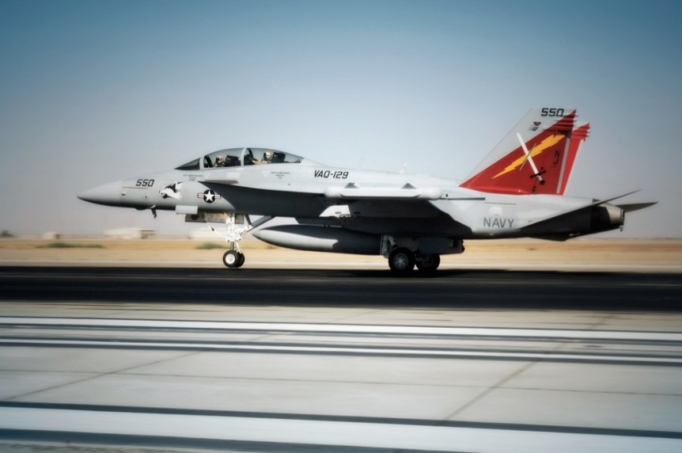
Modern air combat is as much about the opposing electronics as it is about the opposing missiles.
Enter the Growler. It looks very similar to the F/A-18 E/F Super Hornet. It is actually built on a similar platform to the Hornet, its primary mission is to jam radars, sensors and tracking systems — keeping the rest of the air wing focused on their mission. Although outfitted with potent weapons, Growlers mainly prowl the sky for enemy tracking and communication systems to jam.

Description
The EA-18G GROWLER® is a variant of the combat-proven F/A-18F Super Hornet Block II, and will fly the airborne electronic attack mission. The EA-18G combines the capability of the combat-proven Super Hornet with the latest AEA avionics suite evolved from the Improved Capability III (ICAP III) system. The EA-18G’s vast array of sensors and weapons provides the warfighter with a lethal and survivable weapon system to counter current and emerging threats.

Capabilities
Suppression of Enemy Air Defenses: The EA-18G will counter enemy air defenses using both reactive and pre-emptive jamming techniques.
Stand-off and Escort Jamming: The EA-18G will be highly effective in the traditional stand-off jamming mission, but with the speed and agility of a Super Hornet, it will also be effective in the escort role.
Non-Traditional Electronic Attack: Dramatically enhanced situational awareness and uninterrupted communications will enable the EA-18G to achieve a higher degree of integration with ground operations than has been previously achievable.
Self-protect and Time-Critical Strike Support: With its Advanced Electronically Scanned Array (AESA) radar, digital data links and air-to-air missiles, the EA-18G will have self-protection capability and will also be effective for target identification and prosecution.
Growth: High commonality with the F/A-18E/F, nine available weapon stations and modern avionics enable cost-effective synergistic growth for both aircraft, setting the stage for continuous capability enhancement.

Specifications
Crew: Two
Length: 60 ft 1.25 in (18.31 m)
Wingspan: 44 ft 8.5 in (13.62 m) (including wingtip-mounted pods)
Height: 16 ft (4.88 m)
Wing area: 500 ft² (46.5 m²)
Empty weight: 33,094 lb (15,011 kg)
Loaded weight: 48,000 lb (21,772 kg) (recovery weight)
Max takeoff weight: 66,000 lb (29,964 kg)
Powerplant: 2× General Electric F414-GE-400 turbofans
Dry thrust: 14,000 lbf (62.3 kN) each

E-2C HAWKEYE – EYE IN THE SKY
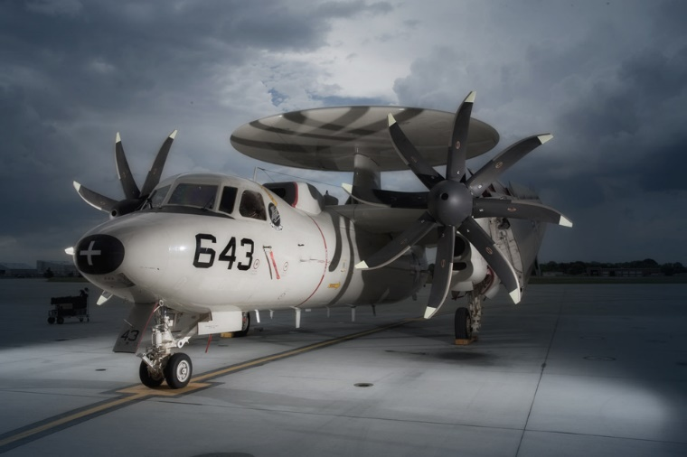
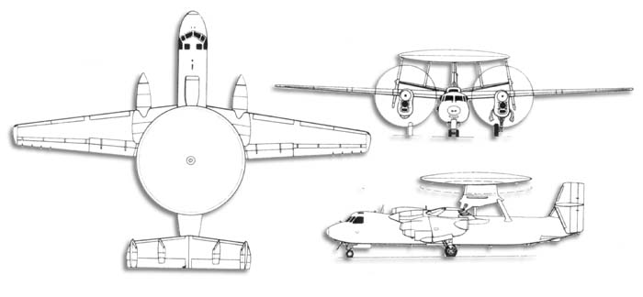
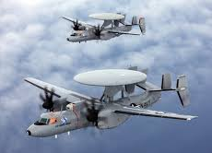
If a Hornet or Lightning is the rifle, the Hawkeye is the scope. Advanced radar, threat analysis equipment, surveillance sensors and more create a potent early-warning system miles out. Like all Navy aircraft, the Hawkeye is multi-mission and can coordinate defense and offense in the air or to the surface.

E-2 HAWKEYE EARLY WARNING AND CONTROL AIRCRAFT

Description
The E-2 Hawkeye is the Navy's all-weather, carrier-based tactical battle management airborne early warning, command and control aircraft. The E-2 is a twin engine, five crewmember, high-wing turboprop aircraft with a 24-foot diameter radar rotodome attached to the upper fuselage.

Features
The Hawkeye provides all-weather airborne early warning, airborne battle management and command and control functions for the Carrier Strike Group and Joint Force Commander. Additional missions include surface surveillance coordination, air interdiction, offensive and defensive counter air control, close air support coordination, time critical strike coordination, search and rescue airborne coordination and communications relay. An integral component of the Carrier Strike Group air wing, the E-2C uses computerized radar, Identification Friend or Foe and electronic surveillance sensors to provide early warning, threat analysis against potentially hostile air and surface targets.

Background
The continuous improvements in early airborne radars by 1956 led to the concept of an airborne early warning and command and control aircraft. The first aircraft to perform this mission was the Grumman E-1 Tracer (a variant of the S-2 Tracker anti-submarine aircraft), which saw service from 1954 to 1964. The E-1's successor, the E-2 Hawkeye, was the first carrier-based aircraft designed from the outset for the all-weather airborne early warning and command and control mission. Since replacing the E-1 in 1964, the Hawkeye has been the "eyes of the fleet." Since its combat debut during the Vietnam conflict, the E-2 has served the Navy around the world.
The current version of the Hawkeye, the E-2C, became operational in 1973, and surpassed one million flight hours in August 2004. The aircraft has undergone several upgrades to its active and passive sensors, engines and propellers. The newest variant of the E-2C (Hawkeye 2000) with its new mission computer, improved radar displays and Cooperative Engagement Capability (CEC), combined with the shipboard Aegis weapon system, will form the cornerstone of future sea based Theater Ballistic Missile Defense (TBMD).
Variants of the E-2C Hawkeye are also flown by the Egyptian Air Force, Japanese Self Defense Air Force, Republic of Singapore Air Force, Taiwan Air Force, and the French Navy.
General Characteristics
Primary Function: Airborne Command & Control, Battle Space Management.
Contractor: Northrop Grumman Aerospace Corp.
Date Deployed: January 1964.
Unit Cost: $80 million.
Propulsion: Two Allison T-56-A427 turboprop engines; (5,100 shaft horsepower each).
Length: 57 feet 6 inches (17.5 meters).
Height: 18 feet 3 inches (5.6 meters).
Wingspan: 80 feet 7 inches (28 meters).
Weight: Max. gross, take-off: 53,000 lbs (23,850 kg) 40,200 lbs basic (18,090 kg).
Airspeed: 300+ knots (345 miles, 552 km. per hour).
Ceiling: 30,000 feet (9,100 meters).
Crew: Five.

C-2A GREYHOUND – FIVE TONS OF CRITICAL LOGISTICS
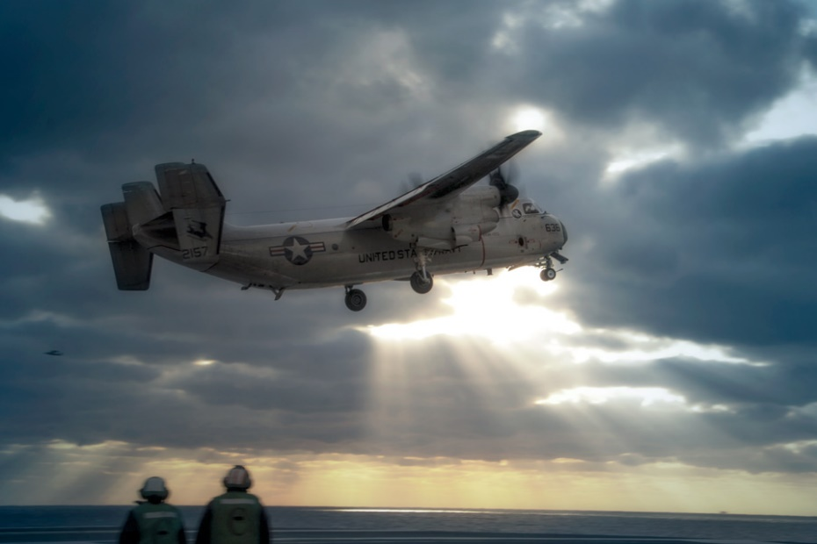
A carrier battle group is a floating metropolis that occasionally has to import and export. And this is the Navy's freight train — with a 10,000-pound payload that can deliver personnel, equipment, spare parts, mail and more to a fleet far out at sea.
As mission-critical as any attack craft, Greyhounds can haul just about anything from sea to ground and back.
Similar to the E-2C Hawkeye, it does not have the “Rotodome” on top of the fuselage.

C-2A GREYHOUND LOGISTICS AIRCRAFT

Description
The C-2A Greyhound is a high wing, twin-engine Carrier Onboard Delivery (COD) aircraft.

Features
Powered by twin Allison T56-A-425 turboprop engines and Hamilton-Sundstrand constant speed propellers, the C-2A Greyhound can transport cargo between ship and shore in a matter of hours. As a derivative of the E-2 Hawkeye, the C-2 has a common wing with the Hawkeye but has a widened fuselage and a rear loading ramp. The interior arrangement of the cabin can accommodate priority cargo like jet engines, passengers, litter patients and critical spare parts. A cargo cage system provides restraint for loads during ship launches and landings. Straight-in rear cargo loading and unloading allows for fast turnaround on the ground or carrier flight-deck. The cargo ramp can be opened in flight, allowing for airdrops of supplies and personnel. An on-board Auxiliary Power Unit (APU) provides aircraft self-sufficiency at remote airfields.
The C-2 fleet provides rapid airborne logistics capability to the carrier strike force across a full range of sea basing military operations. Avionics system improvements, an aircraft electrical rewire and structural enhancements provide the fleet with an economically viable C-2 platform for the duration of its service.

Background
The C-2A Greyhound replaced the piston-engine powered C-1 Trader in the Carrier On-board Delivery role. The first of two prototypes flew in 1964 and production began the following year. The original C-2A aircraft were overhauled to extend their operational life in 1973. In 1984, a contract was awarded for 39 new C-2A aircraft to replace the earlier airframes. Dubbed the Reprocured C-2A due to the similarity to the original aircraft, the new C-2A includes substantial airframe and avionic systems improvements. All the older C-2As were phased out in 1987, and the last of the new models was delivered in 1990.
During the period November 1985 to February 1987, VR-24, operating with seven Reprocured C-2As, demonstrated exceptional operational readiness while delivering two million pounds of cargo, two million pounds of mail and 14,000 passengers in support of the European and Mediterranean Theatre commands. The C-2A also provided support to the Carrier Strike Groups during Operations Desert Shield, Desert Storm, and Operation Enduring Freedom.

General Characteristics
Primary Function: Carrier On-board Delivery (COD) aircraft
Contractor: Grumman Corporation
Unit Cost: $38.96 million
Propulsion: Two Allison T56-A-425 turboprop engines; 4,600 shaft horsepower each
Length: 56 feet 10 inches (17.3 meters)
Height: 17 feet 2 inches (5.28 meters)
Wingspan: 80 feet 7 inches (24.56 meters)
Weight: Max. Gross, take-off: 57,500 lbs (26,082 kg)
Airspeed: Cruise - Approximately 260 knots true airspeed speed; Max - Approximately 343 knots
Ceiling: 30,000 feet (9,144 meters)
Range: 1,000 nautical miles (1150.77945 statute miles)
Crew: Four

MH-60S SEAHAWK

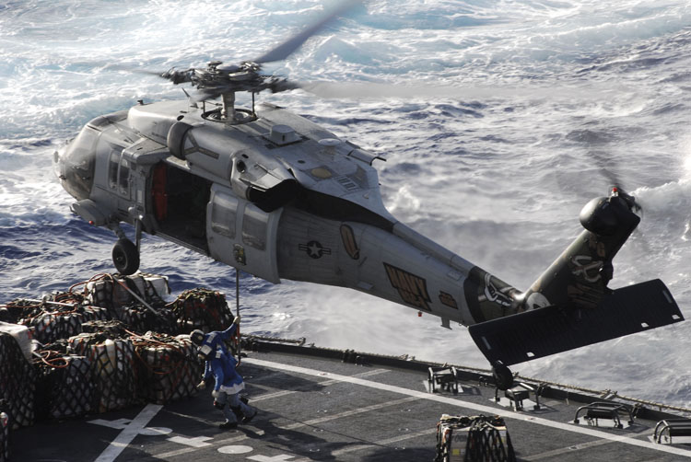
The MH-60S Seahawk missions are Anti-Surface Warfare, combat support, humanitarian disaster relief, Combat Search and Rescue, aero medical evacuation, SPECWAR and organic Airborne Mine Countermeasures.

Description
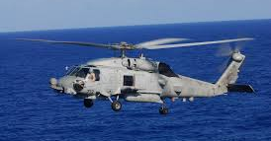
The MH-60S replaced the aging fleet of H-46D helicopters, which led to significant reductions in costs per flight hour, mission aborts, component removals, and unscheduled maintenance actions. The MH-60S with its glass cockpit incorporates active matrix liquid crystal displays, used to facilitate pilot and co-pilot vertical and horizontal situation presentations. Another major design of the MH-60S is a “common cockpit,” which is shared with the new MH-60R. This will allow a pilot to shift from one aircraft to another with minimal re-training.

Specifications
Primary Function: Anti-Surface Warfare, Combat Support, Humanitarian
Contractor: Sikorsky Aircraft Corporation, Lockheed Martin Systems
Date Deployed: 2002
Propulsion: 2-GE T700-GE-401 (C)
Length: 64 feet, 10 inches
Height: 17 feet
Weight: 14,430 lbs (empty), 23,500 lbs (max gross)
Airspeed: 180 knots (max)
Ceiling: 13,000 feet
Range: 245 Nautical Miles
Crew: Four

P-8A POSEIDON – NOTHING GETS PAST IT
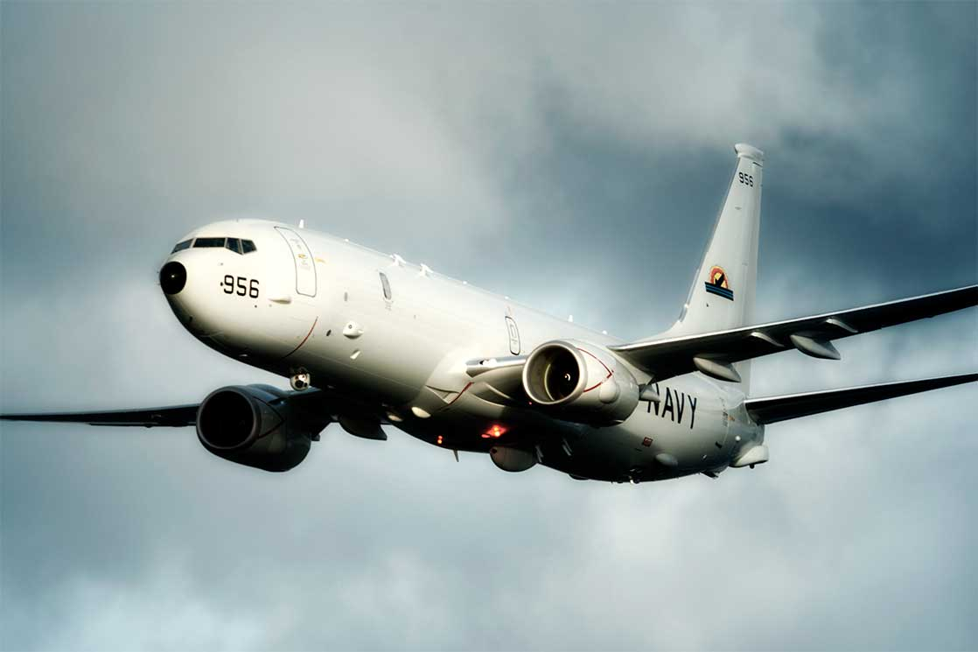
The Poseidon is the jet engine upgrade to the venerable P-3C Orion. The Poseidon is being phased into service to take on the Orion’s old tasks and more, including anti-submarine warfare, anti-surface warfare, shipping interdiction, and electronic signals intelligence. It also carries an impressive array of weapons for its missions, including torpedoes, depth charges, anti-aircraft missiles and anti-ship missiles. On top of that, it can also deploy and monitor sonobuoys.

Get the tech and specs on the P-8A Poseidon.

P-8A POSEIDON MULTI-MISSION MARITIME AIRCRAFT (MMA)
Description
The P-8A Poseidon (P-8A) is the U.S. Navy's multi-mission maritime patrol and reconnaissance aircraft. The P-8A efficiently conducts anti-submarine warfare, anti-surface warfare, intelligence, surveillance, reconnaissance, and humanitarian response. These capabilities are enhanced through secure, interoperable, net-ready systems. While the aircraft is also equipped with high-quality weapon systems, it also has an open architecture to allow for expansion. The P-8A is built for today's missions with room to grow!
Features
The P-8A Poseidon incorporates the 737-800 air frame, -900 wings, a weapons bay and pylons, and operates with a smaller crew. However, it delivers an extended global reach, greater payload capacity, higher operating altitude, and state-of-the art sensors, radars and open-systems architecture.
Background
Designed to secure the U.S Navy's future in long-range maritime patrol capability, the P-8A Poseidon has transformed how the Navy's maritime patrol and reconnaissance force will man, train, operate and deploy. Using an affordable and efficient in-line assembly process, the P-8A Poseidon is built, then, after final assembly, necessary military modifications are added. The P-8A offers commonality with the 737 fleet and other military platforms that use the 737 airframe. Commonality in spares and training for crews reduces costs, and enables military operators to leverage support throughout the world.
Point Of Contact
Naval Air Systems Command/
PMA 290 Public Affairs (301) 757-8690
Building 2185, Suite 3190-B1
22347 Cedar Point Road
Patuxent River, MD 20670-1161
General Characteristics
Primary Function: Anti-Submarine Warfare (ASW) and Anti-surface Warfare (ASuW), Intelligence, Surveillance and Reconnaissance (ISR)
Contractor: Boeing Defense, Space and Security
Propulsion: 2 CFM 56-7B engines with 27,300 lbs. thrust each
Length: 129.5 feet (39.47 meters).
Height: 42.1 feet (12.83 meters).
Wingspan: 123.6 feet (37.64 meters)
Weight: Maximum gross takeoff, 189,200 pounds (85,820 kilograms)
Airspeed: 490 knots (564 mph) true air speed
Ceiling: 41,000 feet (12,496 meters)
Range: 1,200 nautical miles radius with four hours on station
Crew: Nine
Armament: Torpedoes, cruise missiles
Last Update: 3 December 2021

MH-53 E – SUPER STALLION
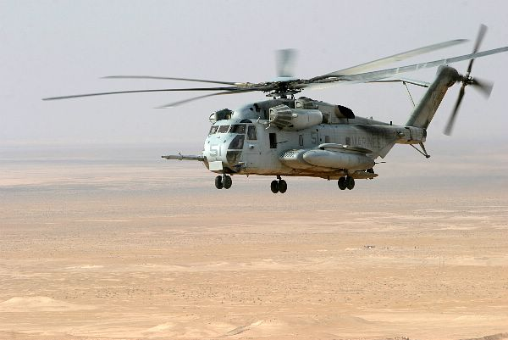
The MH-53E Super Stallion is jointly used by both the US Navy and the US Marine Corps for numerous missions transporting both Marine and Navy manpower as well as supplies, packages, food, and other items required to sustain the Logistics cycle of both Navy and Marine Corps units and US Navy ships throughout the world.
The primary service employing the MH-53E Super Stallion is the US Marine Corps.

CH-53E SUPER STALLION
Description
The CH-53E Super Stallion is the US Marine Corps' primary heavy-lift asset. Its mission is to provide combat assault transport of heavy weapons, equipment, supplies and troops. The CH-53E is critical to the execution of our national security strategy, Navy and Marine Corps warfighting concepts and the associated need for capable heavy-lift. From the Scott O'Grady rescue mission in the Balkans to delivering critically needed combat support in Afghanistan, Iraq and the Horn of Africa, the CH-53E continues to be in high demand.
Features
The CH-53E incorporates Global Positioning System (GPS), Forward-Looking Infrared Radar (FLIR), Aviator Night Vision Imaging Systems Heads Up Display (ANVIS-HUD) sensors, and carries three 50 caliber guns (as a mission kit). Communications include Ultra High Frequency (UHF)/Very High Frequency (VHF)/High Frequency (HF) radios, secure communications capability, and Identified Friend or Foe (IFF).
Background
The CH-53E is the replacement for the CH-53D to satisfy a Marine Corps requirement for a heavy-lift helicopter. Requirement exists to operate the CH-53E through 2030 and its replacement is currently in test and development, the CH-53K King Stallion.
Service
Marine Corps
Point Of Contact
Public Affairs Office
NAVAIR Program Executive Office (A)
47123 Buse RD Bldg 2272 Suite 151.4
Patuxent River, MD 20670-1547
(301) 995-2774
General Characteristics
Primary Function: Combat assault transport of heavy weapons, equipment, supplies and troops.
Contractor: Sikorsky Aircraft, Lockheed Martin Company.
Propulsion: Three T64-GE-416 turboshaft (4,380 SHP each)
Length: 99 feet, 0.5 inches.
Height: 28 feet, 5 inches.
Weight: 73,500 lbs. (39,916 kg) with external load
Airspeed: 172 miles/hour (150 knots)
Ceiling: 10,000 feet (without supplemental oxygen)
Crew: Minimum (three): pilot, copilot, and crew chief. Typical Operational Crew (five): pilot, copilot, crew chief/gunner, aerial observer/gunner, tail gunner.
Last Update: 30 July 2022

V-22 OSPREY TILT-ROTOR AIRCRAFT
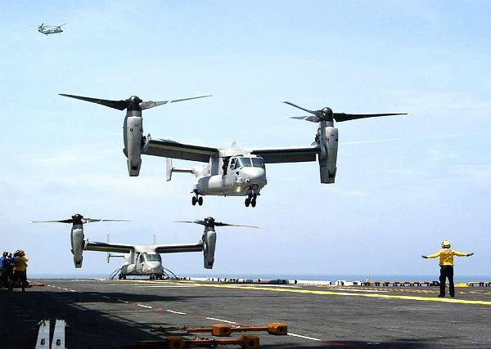

V-22B OSPREY TILT ROTOR AIRCRAFT
Description
The V-22 is a joint service, multi-mission aircraft with vertical take-off and landing (VTOL) capability. It performs VTOL missions as effectively as a conventional helicopter while also having the long-range cruise abilities of a twin turboprop aircraft. More information and photos can be found at The Official V-22 Website.
Features
The Osprey is a tiltrotor aircraft with a 38-foot rotor system and engine/transmission nacelle mounted on each wing tip. It can operate as a helicopter when taking off and landing vertically. Once airborne, the nacelles rotate forward 90 degrees for horizontal flight, converting the V-22 to a high-speed, fuel-efficient turboprop airplane. The wing rotates for compact storage aboard ship.
Background
The V-22 is the world's first production tilt rotor aircraft. The first flight having occurred in March 1989.
The Marine Corps is the lead service in the development of the Osprey. The Marine Corps version, the MV-22B, is an assault transport for troops, equipment and supplies, and will be capable of operating from ships or from expeditionary airfields ashore. The Navy's CMV-22B will provide combat search and rescue, delivery and retrieval of special warfare teams along with fleet logistic support transport. CV-22B is the Air Force Special Operations Command (AFSOC) variant of the U.S. Marine Corps MV-22B Osprey. The CV-22B�s mission is to conduct long-range infiltration, exfiltration and resupply missions for special operations forces.
Planned purchases include 360 for the Marine Corps, 44 for the Navy and 50 for the Air Force.
Service
Navy, Marine Corps and Air Force
Point Of Contact
Naval Air Systems Command
Public Affairs Department
47123 Buse Road, Unit IPT
Bldg. 2272, Suite 075
Patuxent River, MD 20670-5440
(301)995-7909
General Characteristics
Primary Function: Vertical takeoff and landing (VTOL) aircraft.
Contractor: Bell-Boeing.
Propulsion: Two pivoting Rolls-Royce/Allison AE1107C engines.
Rotor Diameter: 38 feet (11.58 meters); Blades per rotor: Three.
Weight: 60,500 lbs max gross weight.
Airspeed: 272 knots (cruise speed).
Ceiling: 25,000 feet (service ceiling).
General Characteristics, MV-22B Osprey
Primary Function: Medium-lift assault support.
Contractor: Bell-Boeing
Date Deployed: 2007
Propulsion: Two Two Rolls-Royce Liberty AE1107C engines, each deliver 6,200 shaft horsepower.
Length: 63 feet
Height: 22 feet, 1 inch with nacelles vertical.
Wingspan: 84.6 feet with rotors turning
Weight: Max. gross, vertical take-off: 52,600 lbs. Short take-off 57,000 lbs
Airspeed: Cruise: 280 knots
Ceiling: 25,000 feet (7,620 meters).
Range: 860 nautical miles
Crew: 3 � pilot, copilot, crew chief; 24 troops
General Characteristics, CV-22B Osprey
Primary Function: Long-range infiltration, exfiltration and resupply missions for special operations forces.
Contractor: Bell-Boeing
Date Deployed: 2009
Propulsion: Two Two Rolls-Royce Liberty AE1107C engines, each deliver 6,200 shaft horsepower.
Length: 63 feet
Height: 22 feet, 1 inch with nacelles vertical.
Wingspan: 84.6 feet with rotors turning
Weight: Max. gross, vertical take-off: 52,600 lbs. Short take-off 57,000 lbs
Airspeed: Cruise: 280 knots
Ceiling: 25,000 feet (7,620 meters).
Range: 2,100 nautical miles with internal auxiliary fuel tanks
Crew: 4 � pilot, copilot, flight engineer, crew chief, ; 24 troops
Last Update: 31 July 2022

